**S-100 – Part 9**

**Portrayal**

Page intentionally left blank

**Contents**

9-1 Scope 1

9-2 Conformance 1

9-3 Normative references 1

9-4 Portrayal Catalogue 2

9-5 General portrayal model 2

9-5.1 The portrayal process 3

9-6 Package overview 3

9-7 Data input schema 4

9-7.1 Introduction 4

9-7.2 Enumerations 4

9-7.3 Coordinates 6

9-7.4 Associations 7

9-7.5 Spatial relations 8

9-7.6 Objects 9

9-7.7 Spatial objects 10

9-7.7.1 Preface 10

9-7.7.2 SpatialObject 11

9-7.7.3 Point 11

9-7.7.4 MultiPoint 11

9-7.7.5 Curve 12

9-7.7.6 CompositeCurve 13

9-7.7.7 Surface 14

9-8 Information objects 14

9-9 Feature objects 14

9-10 Portrayal processing 15

9-11 Drawing Instructions 17

9-11.1 The concepts of drawing instructions 17

9-11.1.1 General concept 17

9-11.1.2 Portrayal Coordinate Reference Systems (CRS) 17

9-11.1.3 Viewing Groups, Viewing Group Layers and Display Mode 17

9-11.1.4 Transparency 17

9-11.1.5 Display Planes 17

9-11.1.6 Display Priorities 18

9-11.1.7 Null Instruction 18

9-11.1.8 Point Instruction 18

9-11.1.9 Line Instruction 18

9-11.1.10 Area Instruction 18

9-11.1.11 Text Instruction 18

9-11.1.12 Coverage Instruction 19

9-11.1.13 Augmented Geometry 19

9-11.2 Model of the Drawing Instruction Package 21

9-11.2.1 DisplayList 21

9-11.2.2 DrawingInstruction 21

9-11.2.3 FeatureReference 22

9-11.2.4 SpatialReference 22

9-11.2.5 AlertReference 22

9-11.2.6 NullInstruction 22

9-11.2.7 PointInstruction 22

9-11.2.8 LineInstruction 23

9-11.2.9 AreaInstruction 23

9-11.2.10 TextInstruction 23

9-11.2.11 CoverageInstruction 23

9-11.2.12 AugmentedGeometry 23

9-11.2.13 AugmentedPoint 23

9-11.2.14 AugmentedLineOrArea 24

9-11.2.15 AugmentedRay 24

9-11.2.16 AugmentedPath 24

9-11.2.17 AugmentedArea 24

9-12 Symbol Definitions 24

9-12.1 Overview 24

9-12.2 The GraphicBase package 25

9-12.2.1 Overview 25

9-12.2.2 Model 25

9-12.3 The Symbol package 29

9-12.3.1 Model 29

9-12.4 The LineStyles package 31

9-12.4.1 Model 31

9-12.5 The AreaFills package 34

9-12.5.1 Model 34

9-12.6 The Text package 37

9-12.6.1 Overview 37

9-12.6.2 Fonts 37

9-12.6.3 Model 37

9-12.7 The Coverage package 40

9-12.7.1 Overview 40

9-12.7.2 Ranges 40

9-12.7.3 Lookup Table 40

9-12.7.4 Model 41

9-13 The portrayal library 43

9-13.1 Overview 43

9-13.2 Structure 43

9-13.3 Model of the Catalogue 44

9-13.3.1 PortrayalCatalog 44

9-13.3.2 CatalogItem 45

9-13.3.3 ExternalFile 45

9-13.3.4 Description 45

9-13.3.5 Pixmaps 45

9-13.3.6 ColorProfiles 46

9-13.3.7 Symbols 46

9-13.3.8 StyleSheets 46

9-13.3.9 LineStyles 46

9-13.3.10 AreaFills 46

9-13.3.11 Fonts 46

9-13.3.12 ViewingGroups 46

9-13.3.13 ViewingGroup 46

9-13.3.14 FoundationMode 47

9-13.3.15 ViewingGroupLayers 47

9-13.3.16 ViewingGroupLayer 47

9-13.3.17 DisplayModes 47

9-13.3.18 DisplayMode 47

9-13.3.19 DisplayPlanes 47

9-13.3.20 DisplayPlane 47

9-13.3.21 Context 48

9-13.3.22 ContextParameter 48

9-13.3.23 Rules 48

9-13.3.24 RuleFile 48

9-13.3.25 ParameterType 48

9-13.3.26 FileFormat 48

9-13.3.27 FileType 49

9-13.3.28 RuleType 49

9-13.4 Model of the alert catalogue 50

9-13.4.1 AlertCatalog 50

9-13.4.2 Messages 50

9-13.4.3 MessageItem 51

9-13.4.4 Text 51

9-13.4.5 Highlights 51

9-13.4.6 GraphicalHighlighting 51

9-13.4.7 ViewingGroupReference 51

9-13.4.8 Alerts 51

9-13.4.9 AlertItem 52

9-13.4.10 AlertInfo 52

9-13.4.11 AlertPriorities 52

9-13.4.12 AlertPrioritySelection 52

9-13.4.13 AlertPriority 52

9-13.5 Schema for pixmap files 53

Appendix 9-A Generating Portrayal Input XML (informative) 56

Preface 56

9-A-1 Input XML structure 56

9-A-2 Simple attributes 56

9-A-3 Complex attributes 57

9-A-4 Information types 57

9-A-5 Spatial Objects 57

9-A-6 Features 57

9-A-7 Associations 58

9-A-8 Example Product Input Dataset 59

Appendix 9-B SVG Profile (normative) 64

9-B-1 Introduction 64

9-B-2 Top Level SVG 64

9-B-2-1 Coordinate System 64

9-B-2-2 Title 64

9-B-2-3 Description 64

9-B-2-4 Metadata 64

9-B-3 Drawing Elements 65

9-B-3-1 Class 65

9-B-3-2 Style Properties 65

9-B-3-3 Path 66

9-B-3-4 Rectangle 66

9-B-3-5 Circle 66

Page intentionally left blank

# Scope

This part of the standard defines the models, structures and formats for a machine readable Portrayal Catalogue. The intent is for a Portrayal Catalogue to be delivered separately from product datasets such that it can be imported and interpreted to map Feature objects defined according to the Part 3 General Feature Model (GFM) into Drawing Instructions and symbolization.

The actual contents of a Portrayal Catalogue need to be defined as part of a Product Specification using the mechanism and structures defined in this part. For example a product specification would include a set of mapping rules, a set of symbols, linestyles, colors etc and make it available for use with product datasets.

This part includes mechanisms for portrayal of 2D vector data according to the GFM as well as Coverage data. It does not include drawing instructions and symbol structures intended for 3D portrayal. It does not include the generation of pick reports or textual reports however the approach of exposing the content to mapping rules could be implemented to generate textual or html formatted output.

# Conformance

This part of the specification conforms to ISO 19117:2012 (E) according to the Annex A Abstract test suite.

# Normative references

The following referenced documents are required for the application of this document. For dated references, only the edition cited applies. For undated references, the latest edition of the referenced document (including amendments) applies.

ICC Specification Version 4 – International Color Consortium

ISO 19117: 2012 (E), *Geographic Information – Portrayal*

W3C.REC-XSLT-1.0-19991116, XSL Transformations (XSLT) Version 1.0, *W3C Recommendation* 16 November 1999, <<http://www.w3.org/TR/xslt>>

W3C.REC-SVGTiny12-20081222, Scalable Vector Graphics (SVG) Tiny 1.2 Specification, *W3C Recommendation* 22 December 2008***,*** <<http://www.w3.org/TR/2008/REC-SVGTiny12-20081222>>

W3C.REC-CSS2-20110607, *Cascading Style Sheets Level 2 Revision 1 (CSS 2.1) Specification, W3C Recommendation* 07 June 2011,<<http://www.w3.org/TR/2011/REC-CSS2-20110607>>

TrueType-1.66-1995, *True Type Font Revision 1.66* 1995, <<http://www.microsoft.com/typography/SpecificationsOverview.mspx>>

# Portrayal Catalogue

This part of the standard describes a Portrayal Catalogue and its contents. The concept in this standard is that feature data is modelled with a focus on content and portrayal of a feature is accomplished using rules or functions that map the content to the appropriate symbols and display characteristics. This concept allows the same content to be displayed in different ways and allows the display mapping rules to be maintained without having to modify all the content data.

The Portrayal Catalogue contains portrayal functions that map the features to symbology it also contains symbol definitions, colour definitions, portrayal parameters and portrayal management concepts such as viewing groups. The goal in S-100 is to provide a mechanism where, for a given product, the portrayal catalogue can be delivered as data in a machine readable form such that a compliant implementation can display the product feature data using the given Portrayal Catalogue.

# General portrayal model

The general portrayal model is illustrated in figure 9.1.

Portrayal Engine

Rendering Engine

Feature Data

Portrayal functions

Drawing Instructions

Portrayal Output

Symbol Definitions

Figure 9-1 — General portrayal model

This part of S-100 defines a feature-centred function-based portrayal mechanism. Instances of features are portrayed based on portrayal functions, which make use of geometry and attribute information. The relationship between the feature instances, attributes, and the underlying spatial geometry is specified in a product specification based on the General Feature Model of S-100.

Portrayal information is needed to portray a dataset containing geographic data. The portrayal information is defined as drawing instructions created by specific portrayal functions. The portrayal mechanism makes it possible to portray the same dataset in different ways without altering the dataset itself.

The drawing instructions are intermediate data used by the rendering engine to produce the portayal output. During the rendering process, the rendering engine uses the symbol definitions to create the output according to the output device.

The symbol definitions contain the details of all graphical elements used for the portrayal. The model of the symbol definitions is described in this document.

## The portrayal process

System Database

Feature Data

Portrayal View

XSLT Processor

Drawing Instructions

**Portrayal Input XML Schema**

**XSLT templates**

Portrayal  
Functions

**Drawing Instructions XML Schema**

Context

**User parameters**

System Portrayal Engine

Figure 9-2 — Portrayal process

The system has Feature data within its internal database that needs to be portrayed. The System Portrayal Engine transforms the Feature data into drawing instructions. Drawing instructions include such things as references to symbol definitions, priority and filtering information. The drawing instructions are further processed by the rendering engine to produce the final display.

In this process, feature data needs to be exposed to the XSLT processor as XML content. The XSLT processor applies the best matching template or portrayal function to each feature. The portrayal function uses the defined logic to transform the input feature content along with related context information into drawing instructions which are output as XML.

The functionality of the System Portrayal Engine is defined in terms of XSLT. XSLT is a declarative language. An XSLT processor transforms XML input into XML output. Contextual and user parameters can be fed into the XSLT processor for use by the portrayal functions. Portrayal functions in XSLT can range from simple lookup or best match templates to complex conditional logic. XSLT is defined to work on an XML node tree however there are implementations that interface the XSLT processor directly with internal structures or relational database tables. Although there are newer versions of XSLT, XSLT 1.0 (http://www.w3.org/TR/xslt) has been chosen for this portrayal specification as the most commonly supported.

This portrayal specification defines how machine readable portrayal transformation functions are implemented as XSLT templates disseminated in XSL files. Since XSLT is defined to operate on XML and produce XML the XML input and output are described as part of this specification. A conformant System Portrayal Engine must operate consistently with XSLT in order to process the machine readable XSL files and produce equivalent output.

# Package overview

The following diagram shows the packages for implementing this standard.

The InputSchema describes how data is presented to the portrayal engine (XSLT processor). The Presentation package includes two subpackages one describing the portrayal catalogue structure the other describing the drawing instructions. Drawing instructions are the output of the portrayal engine (XSLT processor)

The SymbolDefinitions package describes the graphic primitives used for portrayal.

The portrayal engine is using standard XSLT. There is no package describing this part of the portrayal.

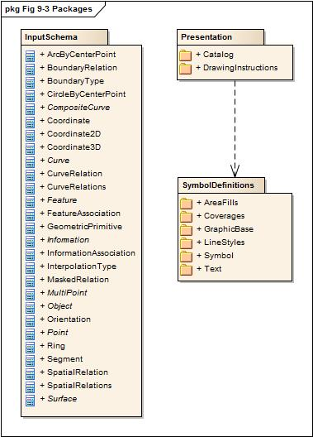

Figure 9-3 — Packages

# Data input schema

## Introduction

The data input schema describes how data should be presented to the XSLT processor. Encoded data can be transformed to an XML document or a presentation of such a document, for example a DOM-tree. It is also possible to model the data to look like XML and use a special software interface to present such data to the XSLT processor.

Whichever method is used, this schema describes how the data must be organized. In this standard only the base types are described. These types should be used along with a products feature catalogue to generate the input XML for portrayal processing, as described in Annex A.

NOTE It is assumed for the examples in this section that types of this schema are in the namespace s100.

## Enumerations

For the use in this schema the following enumeration types are defined:

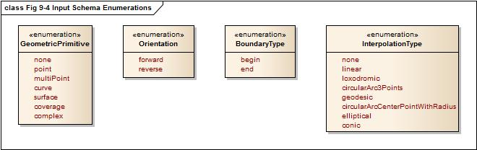

Figure 9-4 — Input Schema Enumerations

**GeometricPrimitive**

This enumeration describes the type of geometric primitive that is used by a feature object. If the feature object uses different geometric primitives the value Complex has to be used.

<xs:simpleType name="GeometricPrimitive">  
 <xs:restriction base="xs:string">  
 <xs:enumeration value="None"/>  
 <xs:enumeration value="Point"/>  
 <xs:enumeration value="MultiPoint"/>  
 <xs:enumeration value="Curve"/>  
 <xs:enumeration value="Surface"/>  
 <xs:enumeration value="Coverage"/>  
 <xs:enumeration value="Complex"/>   
 </xs:restriction>  
</xs:simpleType>

**Orientation**

The enumeration Orientation is used to specify the orientation of a referenced geometry that is used by a feature object or by a complex curve.

<xs:simpleType name="Orientation">  
 <xs:restriction base="xs:string">  
 <xs:enumeration value="Forward"/>  
 <xs:enumeration value="Reverse"/>  
 </xs:restriction>  
</xs:simpleType>

**BoundaryType**

This enumeration describes the type of a topologic boundary.

<xs:simpleType name="BoundaryType">  
 <xs:restriction base="xs:string">  
 <xs:enumeration value="Begin"/>  
 <xs:enumeration value="End"/>  
 </xs:restriction>  
</xs:simpleType>

**InterpolationType**

This enumeration describes the mathematical interpolation method between two control points in a line segment. Note that the methods depend on the underlying coordinate reference system and not all of them are valid for all types of CRS. The product specification should specify the details of the use of interpolation.

<xs:simpleType name="InterpolationType">  
 <xs:restriction base="xs:string">  
 <xs:enumeration value="None"/>  
 <xs:enumeration value="Linear"/>  
 <xs:enumeration value="Loxodromic"/>  
 <xs:enumeration value="CircularArc3Points"/>  
 <xs:enumeration value="Geodesic"/>  
 <xs:enumeration value="CircularArcCenterPointWithRadius"/>  
 <xs:enumeration value="Elliptical"/>  
 <xs:enumeration value="Conic"/>  
 <xs:enumeration value="PolynomialSpline"/>  
 <xs:enumeration value="BezierSpline"/>  
 <xs:enumeration value="BSpline"/>  
 <xs:enumeration value="BlendedParabolic"/>  
 </xs:restriction>  
</xs:simpleType>

## Coordinates

In case that coordinates have to be presented to the XSLT processor the following types have to be used.

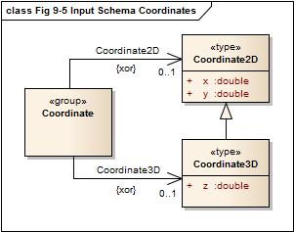

Figure 9-5 — Input Schema Coordinates

The types Coordinate2D and Coordinate3D are for a simple coordinate tuple. They are defined as:

<xs:complexType name="Coordinate2D">  
 <xs:sequence>  
 <xs:element name="x" type="xs:double"/>  
 <xs:element name="y" type="xs:double"/>  
 </xs:sequence>  
</xs:complexType>  
  
<xs:complexType name="Coordinate3D">  
 <xs:complexContent>  
 <xs:extension base="Coordinate2D">  
 <xs:sequence>  
 <xs:element name="z" type="xs:double"/>  
 </xs:sequence>  
 </xs:extension>  
 </xs:complexContent>  
</xs:complexType>

Note that the type Coordinate3D is an extension of the type Coordinate2D.

**Example:**

<s100:Coordinate2D>  
 <s100:x>9.12345</s100:x>  
 <s100:y>52.56789</s100:y>  
</s100:Coordinate2D>

And

<s100:Coordinate2D>  
 <s100:x>9.12345</s100:x>  
 <s100:y>52.56789</s100:y>  
 <s100:z>12.5</s100:z>  
</s100:Coordinate2D>

A group Coordinate is defined where coordinate tuples can be used. The use of 2D or 3D tuples is mutually exclusive.

<xs:group name="Coordinate">  
 <xs:choice>  
 <xs:element name="Coordinate2D" type="Coordinate2D"/>  
 <xs:element name="Coordinate3D" type="Coordinate3D"/>  
 </xs:choice>  
</xs:group>

## Associations

According to the general feature model there are two types of associations:

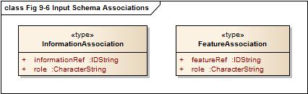

Figure 9-6 — Input Schema Associations

For each association a separate type is defined in the schema:

<xs:complexType name="InformationAssociation">  
 <xs:attribute name="informationRef" type="IDString" use="required"/>  
 <xs:attribute name="role" type="xs:string" use="required"/>  
</xs:complexType>

<xs:complexType name="FeatureAssociation">  
 <xs:attribute name="featureRef" type=" IDString " use="required"/>  
 <xs:attribute name="role" type="xs:string" use="required"/>  
</xs:complexType>

The attributes informationRef and featureRef correspond to the attribute id of the referenced information respective feature object. See the section on objects for more details.

Each S100_FC_InformationAssociation and S100_FC_FeatureAssociation defined in a feature catalogue describes a subtype of InformationAssociation and FeatureAssociation respectively. These subtypes may define additional attributes of the association, these attributes should be included in the input XML as described in Annex A.

## Spatial relations

In the general feature model different relations are modelled between feature types and spatial types but also between spatial types. For such relations the following types are defined by this schema.

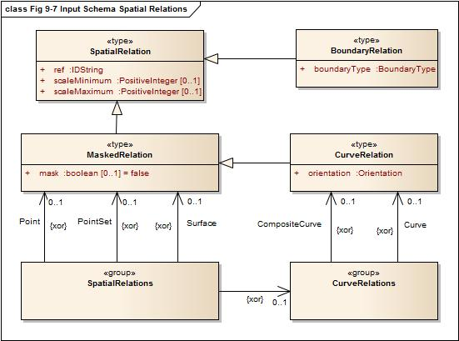

Figure 9-7 — Input Schema Spatial Relations

The type SpatialRelation is the base type for all relations to spatial objects. The ref attribute corresponds to the attribute id of the spatial object.

<xs:complexType name="SpatialRelation">  
 <xs:attribute name="ref" type=" IDString " use="required"/>  
 <xs:attribute name="scaleMinimum" type="xs:positiveInteger" use="required"/>  
 <xs:attribute name=" scaleMaximum " type="xs:positiveInteger" use="required"/>  
</xs:complexType>

The other relation types are derived from this type and add information according to the specific use of that relation. The type MaskedRelation adds an attribute mask that specifies if a referenced spatial object should not be used for portrayal.

<xs:complexType name="MaskedRelation">  
 <xs:complexContent>  
 <xs:extension base="SpatialRelation">  
 <xs:attribute name="mask" type="xs:boolean" default="false"/>  
 </xs:extension>  
 </xs:complexContent>  
</xs:complexType>

Note that the attribute mask is not mandatory but has a default value for the case of its absence.

The type BoundaryRelation adds a boundary type to the relation and is used when the relation describes a topological relation, for example the relation to a bounding node of a curve.

<xs:complexType name="BoundaryRelation">  
 <xs:complexContent>  
 <xs:extension base="SpatialRelation">  
 <xs:attribute name="boundaryType" type="BoundaryType" use="required"/>  
 </xs:extension>  
 </xs:complexContent>  
</xs:complexType>

The type CurveRelation is used whenever a curve is referenced by a spatial relation since it is necessary to specify if the curve is used in the same direction as it is defined or in the reverse order. The type is derived from MaskedRelation since each curve can be a subject of masking.

<xs:complexType name="CurveRelation">  
 <xs:complexContent>  
 <xs:extension base="MaskedRelation">  
 <xs:attribute name="orientation" type="Orientation" use="required"/>  
 </xs:extension>  
 </xs:complexContent>  
</xs:complexType>

Two groups are defined for Spatial relations. One group defines the possible relations to curves; the other defines all possible spatial relations.

<xs:group name="CurveRelations">  
 <xs:choice>  
 <xs:element name="Curve" type="CurveRelation"/>  
 <xs:element name="CompositeCurve" type="CurveRelation"/>  
 </xs:choice>  
</xs:group>  
  
<xs:group name="SpatialRelations">  
 <xs:choice>  
 <xs:element name="Point" type="MaskedRelation"/>  
 <xs:element name="PointSet" type="MaskedRelation"/>  
 <xs:element name="Surface" type="MaskedRelation"/>  
 <xs:group ref="CurveRelations"/>  
 </xs:choice>  
</xs:group>

How these groups are used is demonstrated in Annex A.

## Objects

All objects in a data set are based on the type Object which carries the common properties of all objects. The only commonality on objects is the identifier. Each object needs to be uniquely identifiable within a data set. This is done by the attribute id.

<xs:complexType name="Object" abstract="true">  
 <xs:attribute name="id" type="IDString" use="required"/>  
</xs:complexType>

Note that the type of the identifier is IDString to be as general as possible with respect to different methods used for identification. The characters allowed in this string are 0-9a-zA-Z.

<xs:simpleType name="IDString">

<xs:restriction base="xs:string">

<xs:minLength value="1"/>

<xs:pattern value="[0-9a-zA-Z_]*"/>

</xs:restriction>

</xs:simpleType>

The model of all objects is given in following diagram.

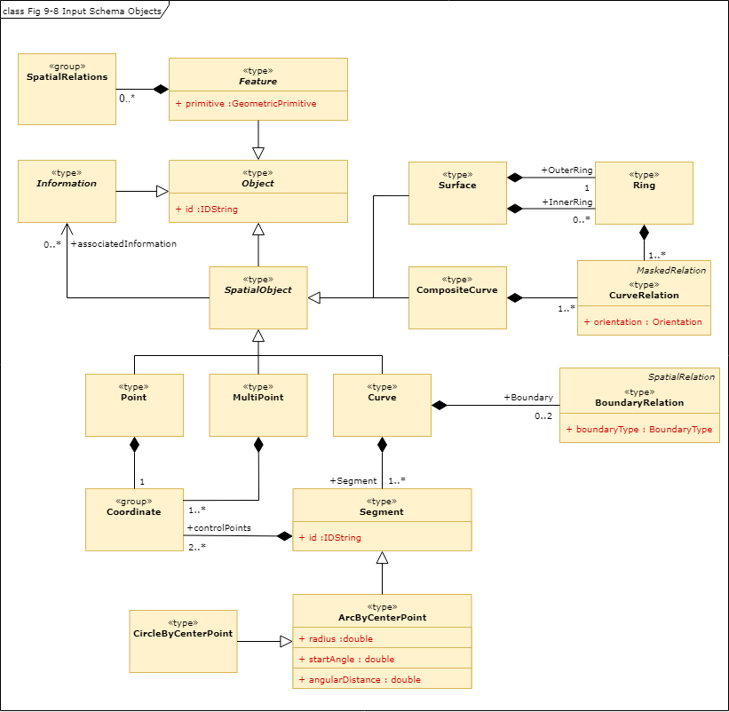

Figure 9-8 — Input Schema Objects

## Spatial objects

### Preface

Spatial objects in a data set carry the geometric location of a feature object. The following types are supported by this standard:

* Point
* MultiPoint
* Curve
* Composite curve
* Surface

Attributes are not permitted for spatial objects by the GFM. All types are derived from the type Object, meaning they have an identifier.

### SpatialObject

SpatialObject is an abstract class which serves as the base class for all spatial objects. It provides a one-way association to Information, which can be used to provide spatial quality or other information for any spatial object.

When an association is present, the code of an information association defined in the feature catalogue should be used as the element name in place of *associatedInformation* - see Annex A for more information.

<xs:complexType name="SpatialObject" abstract="true">  
 <xs:complexContent>  
 <xs:extension base="Object">  
 <xs:sequence>  
 <xs:element name="associatedInformation" type="InformationAssociation" minOccurs="0"

maxOccurs="unbounded"/>

<!—When generating input XML the base schema should be extended to provide a substitution group for each information association defined in the feature catalogue. For example, if the feature catalogue defines an information association having a code of SpatialAssociation, the base schema should be extended with:

<xs:element name="SpatialAssociation" substitutionGroup="associatedInformation"/>

-->

</xs:sequence>  
 </xs:extension>  
 </xs:complexContent>  
</xs:complexType>

### Point

A point carries a single coordinate tuple, 2D or 3D. The definition looks like.

<xs:complexType name="Point">  
 <xs:complexContent>  
 <xs:extension base="SpatialObject">  
 <xs:sequence>  
 <xs:group ref="Coordinate"/>  
 </xs:sequence>  
 </xs:extension>  
 </xs:complexContent>  
</xs:complexType>

Note that the group Coordinate is used within the definition to allow both Coordinate2D and Coordinate3D elements

### MultiPoint

Similar to Point this type defines point geometry for a feature object. The difference is that a set of tuples can be defined. Therefore maxOccurs is set to unbounded.

<xs:complexType name="MultiPoint">  
 <xs:complexContent>  
 <xs:extension base="SpatialObject">  
 <xs:sequence>  
 <xs:group ref="Coordinate" minOccurs="1" maxOccurs="unbounded"/>  
 </xs:sequence>  
 </xs:extension>  
 </xs:complexContent>  
</xs:complexType>

### Curve

Curves describe the line geometry of a feature object. They are made of segments where each segment has a sequence of control points and an interpolation method. The latter defines the geometry between the control points according to the used coordinate reference system. There are two special types of segments:

1. ArcByCenterPoint  
   A circular arc defined by a center point and a radius. The beginning of the arc is defined by the start angle and the length of the arc is defined by the angular length. This length is a signed quantity defining the direction of the arc: positive means clockwise.
2. CircleByCenterPoint  
   A circle defined by a center point and a radius.

The abstract type SegmentBase defines a sequence of control points and the attribute for the interpolation type:

<xs:complexType name="SegmentBase" abstract="true">  
 <xs:sequence>  
 <xs:element name="ControlPoint" type="Coordinate2D" minOccurs="1" maxOccurs="unbounded"/>  
 </xs:sequence>  
 <xs:attribute name="interpolation" type="InterpolationType" use="required"/>  
</xs:complexType>

From this type the type Segment is derived by restricting the number of control points to at least two:

<xs:complexType name="Segment">  
 <xs:complexContent>  
 <xs:restriction base="SegmentBase">  
 <xs:sequence>  
 <xs:element name="ControlPoint" type="Coordinate2D" minOccurs="2" maxOccurs="unbounded"/>  
 </xs:sequence>  
 </xs:restriction>  
 </xs:complexContent>  
</xs:complexType>

For the “by center point” segments the abstract base type is also derived from SegmentBase restricting the number of control points to exact 1 and fixes the value of the attribute interpolation.

<xs:complexType name="ArcByCenterPointBase" abstract="true">  
 <xs:complexContent>  
 <xs:restriction base="SegmentBase">  
 <xs:sequence>  
 <xs:element name="ControlPoint" type="Coordinate2D" minOccurs="1" maxOccurs="1"/>  
 </xs:sequence>  
 <xs:attribute name="interpolation" type="InterpolationType" use="required"   
 fixed="CircularArcCenterPointWithRadius"/>  
 </xs:restriction>  
 </xs:complexContent>  
</xs:complexType>

The ArcByCenterPoint is then an extension of this type adding attributes for radius, start angle and angular length.

<xs:complexType name="ArcByCenterPoint">  
 <xs:complexContent>  
 <xs:extension base="ArcByCenterPointBase">  
 <xs:attribute name="radius" type="xs:double" use="required"/>  
 <xs:attribute name="startAngle" type="xs:double" use="required"/>  
 <xs:attribute name="angularDistance" type="xs:double" use="required"/>  
 </xs:extension>  
 </xs:complexContent>  
</xs:complexType>

The CircleByCenterPoint type is very similar. The attribute start angle is not defined since it is meaningless. The direction is here defined by the attribute direction which has values ‘+’ or ‘-‘.

<xs:simpleType name="Direction">  
 <xs:restriction base="xs:string">  
 <xs:enumeration value="+"/>  
 <xs:enumeration value="-"/>  
 </xs:restriction>  
</xs:simpleType>

<xs:complexType name="CircleByCenterPoint">  
 <xs:complexContent>  
 <xs:extension base="ArcByCenterPointBase">  
 <xs:attribute name="radius" type="xs:double" use="required"/>  
 <xs:attribute name="direction" type="Direction" default="+"/>  
 </xs:extension>  
 </xs:complexContent>  
</xs:complexType>

A group is defined that allows the use of the different type of segments.

<xs:group name="Segments">  
 <xs:choice>  
 <xs:element name="Segment" type="Segment"/>  
 <xs:element name="ArcByCenterPoint" type="ArcByCenterPoint"/>  
 <xs:element name="CircleByCenterPoint" type="CircleByCenterPoint"/>  
 </xs:choice>  
 </xs:group>

The type Curve finally combines a sequence of segments with the topological boundary. The topological boundary of a curve is the beginning and end node implemented by a Point object.

<xs:complexType name="Curve">  
 <xs:complexContent>  
 <xs:extension base="SpatialObject">  
 <xs:sequence>  
 <xs:element name="Boundary" type="BoundaryRelation" minOccurs="0" maxOccurs="2"/>  
 <xs:group ref="Segments" minOccurs="1" maxOccurs="unbounded"/>  
 </xs:sequence>  
 </xs:extension>  
 </xs:complexContent>  
</xs:complexType>

### CompositeCurve

A composite curve describes the line geometry of a feature object just like a ‘simple’ curve. But instead of using coordinates to define the geometry it is using a sequence of other curves, including other composite curves. With other words it is a sequence of relations to other curves.

<xs:complexType name="CompositeCurve">  
 <xs:complexContent>  
 <xs:extension base="SpatialObject">  
 <xs:sequence>  
 <xs:group ref="CurveRelations" minOccurs="1" maxOccurs="unbounded"/>  
 </xs:sequence>  
 </xs:extension>  
 </xs:complexContent>  
</xs:complexType>

### Surface

Surfaces describe the area geometry of a feature object. The surface itself is defined by its boundary. The boundary consists of an outer ring and optionally a number of inner rings. The inner rings describe holes in the area. Each ring is a closed polygon made from one or many curves. That means that a ring is very similar to a composite curve but unlike the composite curve it is not derived from SpatialObject because it does not need to be identifiable. The definition of a ring simply looks like:

<xs:complexType name="Ring">  
 <xs:group ref="CurveRelations" minOccurs="1" maxOccurs="unbounded"/>  
</xs:complexType>

And the definition of a surface finally is:

<xs:complexType name="Surface">  
 <xs:complexContent>  
 <xs:extension base="SpatialObject">  
 <xs:sequence>  
 <xs:element name="OuterRing" type="Ring"/>   
 <xs:element name="InnerRing" type="Ring" minOccurs="0" maxOccurs="unbounded"/>   
 </xs:sequence>  
 </xs:extension>  
 </xs:complexContent>  
</xs:complexType>

# Information objects

Information object are identifiable and sharable pieces of information within a data set. In the model an abstract type Information is derived from the type Object. Although no additional properties are added, this type is useful for semantic reasons.

<xs:complexType name="Information" abstract="true">  
 <xs:complexContent>  
 <xs:extension base="Object"/>  
 </xs:complexContent>  
</xs:complexType>

# Feature objects

Feature objects are abstractions of real world phenomena. This schema defines the abstract base type for any feature type. The type Feature is derived from Object and adds a sequence of spatial relations and a geometric primitive attribute to the properties from the base class, as well as optional associations to information and / or other features.

When an association is present, the code of an information association or feature association defined in the feature catalogue should be used as the element name in place of *associatedInformation* or *associatedFeature* respectively - see Annex A for more information.

<xs:complexType name="Feature" abstract="true">  
 <xs:complexContent>  
 <xs:extension base="Object">  
 <xs:sequence>  
 <xs:group ref="SpatialRelations" minOccurs="0" maxOccurs="unbounded"/>  
 <xs:element name="associatedInformation" type="InformationAssociation" minOccurs="0" maxOccurs="unbounded"/>

<!—When generating input XML the base schema should be extended to provide a substitution group for each information association defined in the feature catalogue. For example, if the feature catalogue defines an information association having a code of AdditionalInformation, the base schema should be extended with:

<xs:element name="AdditionalInformation" substitutionGroup="associatedInformation"/>

-->

<xs:element name="associatedFeature" type="FeatureAssociation" minOccurs="0"

maxOccurs="unbounded"/>

<!—When generating input XML the base schema should be extended to provide a substitution group for each feature association defined in the feature catalogue. For example, if the feature catalogue defines a feature association having a code of StructureEquipment, the base schema should be extended with:

<xs:element name="StructureEquipment" substitutionGroup="associatedFeature"/>

-->

</xs:sequence>  
 <xs:attribute name="primitive" type="GeometricPrimitive" use="required"/>  
 </xs:extension>  
 </xs:complexContent>  
</xs:complexType>

# Portrayal processing

This specification is referencing XSLT 1.0 which is a W3C recommendation, <http://www.w3.org/TR/xslt>

XSLT uses XPath 1.0 to address components of a document. <http://www.w3.org/TR/xpath/>

XSLT (XSL Transformations) is a language expressed as a well formed XML document. The intended purpose of using XSLT in portrayal is to transform the data into drawing instructions. Since XSLT is expressed in XML it is useful for interchange as a machine readable transformation language. XSLT is widely used across many domains but is perhaps most commonly used to transform XML documents into HTML for web page displays. There are many tutorials, books and reference material available for XSLT. There are also several web sites where questions can be posted and examples can be found.

XSLT uses templates to process nodes in the input XML tree and generate nodes as output XML, other SGML formats or even plain text. There are two types of templates a matching template and a named template.

Matching templates use a matching expression using XPATH to specify what elements in the input document should be processed by that template. XPATH (XML Path Language) is an expression language used to address or find components in an XML document. The path capability makes it especially useful when dealing with a hierarchy of content such as nested complex attributes. Only one matching template can match an element from the input document. Matching templates have a built in priority calculation and conflict resolution method that is used to determine which one to use in the case where multiple templates match the same element. Priority numbers can be explicitly assigned as an attribute of a matching template in order to override the default conflict resolution behaviour.

Named templates are called by another template along with the data to be processed. Named templates can also have parameters. These are useful for formatting or other operations that are commonly used in a transformation. A named template can even call itself (recursion), which can be useful for operations such as string token parsing.

A template can loop over a set of nodes that match an XPath expression using an “xsl:apply-templates “ or “xsl:for-each” instruction element. The nodes can also be sorted before being processed. Conditional processing is available by using a simple “xsl:if” instruction or an “xsl:choose” instruction. The choose instruction allows a set of expressions to be tested such that only the first one matching is processed and if no match is found an optional otherwise statement is used to handle a default. This is useful for testing enumerated data such that a different output is generated depending upon the enumeration value.

XSLT also includes the ability to have parameters passed at the top level and accessed within any of the templates. These parameters can be useful to provide contextual information to the transformation. There are also variables in XSLT but they can only be assigned data as part of their definition, unlike other languages where variables can be reassigned. Variables are useful to collect data or decision results that can be passed as parameters to another template or used in conditional statements.

XSLT can include or import other XSLT documents. This capability can be useful for management of templates and reuse of templates by multiple top level XLST documents.

**Examples**

Given the example XML below

<BeaconCardinal id="2">  
 <s100:Point ref="3"/>  
 <categoryOfCardinalMark>3</categoryOfCardinalMark>  
 </BeaconCardinal>  
 <BeaconCardinal id="3">  
 <s100:Point ref="3"/>  
 <categoryOfCardinalMark>2</categoryOfCardinalMark>  
 </BeaconCardinal>

A simple matching XSLT template used as a portrayal function

<xsl:template match="BeaconCardinal">

<!—This is a comment. This template matches a BeaconCardinal node and the body of the template can examine data and output results -->

</xsl:template>

The above template will be used to process all of the BeaconCardinal objects.

The choose instruction can be used to do conditional processing within the template.

<xsl:template match="BeaconCardinal">

<xsl:choose>

<xsl:when test="categoryOfCardinalMark = '2'">

<!-- Output symbol for BeaconCardinal categoryOfCardinalMark =2 here -->

</xsl:when>

<xsl:when test="categoryOfCardinalMark = '3'">

<!-- Output symbol for BeaconCardinal categoryOfCardinalMark =3 here -->

</xsl:when>

<xsl:otherwise>

<!-- Output default symbol here -->

</xsl:otherwise>

</xsl:choose>

</xsl:template>

A more advanced XPath expression can be used to refine the match.

<xsl:template match="BeaconCardinal[categoryOfCardinalMark=2] ">

<!—This is a comment. Output symbol for BeaconCardinal categoryOfCardinalMark =2 here -->

</xsl:template>

# Drawing Instructions

## The concepts of drawing instructions

### General concept

The output of the portrayal engine is a set of drawing instructions, which link the feature type to a symbol and/or alert reference. The geometry is either taken from the feature type or can be generated by the portrayal functions. The latter is supported by the concept of augmented geometry.

### Portrayal Coordinate Reference Systems (CRS)

In this context coordinate reference systems refer to the portrayal geometry only.

There are different CRS related to the portrayal:

* Geographic CRS
* Portrayal CRS
* Local CRS
* Line CRS
* Area CRS
* Tile CRS
* Hatch CRS

Geographic CRS are used in the geographic dataset that are portrayed. They will be mapped by means of projections and affine transformation to the Portrayal CRS. Nevertheless rotations of symbols may be still defined relative to the North-Axis of the Geographic CRS.

The Portrayal CRS defines the coordinates at the output device, for example a screen or pixmap.

Line symbols have two kinds of coordinate reference systems. The line coordinate reference system is a non-Cartesian 2-axis coordinate system. The x-axis is following the line geometry and the y-axis is perpendicular to the geometry of the curve. This CRS allows for the specification of line widths,offsets and symbols following the geometry. The second kind of coordinate reference system is a local Cartesian coordinate reference system which is defined for every location along a curve. This coordinate reference system has an x-axis that is tangential to the curve and a y-axis perpendicular to the x-axis.

An area symbol defines coordinate reference systems for its boundary and for its interior. The boundary coordinate reference systems are those defined for line symbols. The interior of the area symbol has its own coordinate reference system.

For tiled pattern and hatch patterns own CRS are defined.

### Viewing Groups, Viewing Group Layers and Display Mode

The viewing group is a concept to control the content of the display. It works as an on/off switch for any drawing instruction assigned to the corresponding viewing group. The concept can be seen as a filter on the list of drawing instructions.

Viewing groups can be aggregated into Viewing Group Layers and Viewing Group Layer can be aggregated into Display Modes. Both aggregations are part of the portrayal catalogue.

### Transparency

Additive effects of applying transparencies shall be accomplished by multiplying the component alpha values. For example, a color token which has transparency of 10% which is drawn with a transparency of 20% shall result in (1 – 10%) * (1 – 20%) = 72% alpha = 28% transparency.

### Display Planes

Display planes are a concept to split the output of the portrayal functions into separate lists. An example of this is the separation of chart information drawn under a radar image and chart information drawn over a radar image.

### Display Priorities

Display priorities control the order in which the output of the portrayal functions is processed by the rendering engine. Priorities with smaller numerical values will be processed first. Instructions which have equal display priority must be ordered so that area instructions are rendered first, followed by line instructions, then point instructions, and lastly text instructions. If the display priority is equal among the same type of instruction (area, line, point, or text) some other neutral criterion must be used to order the instructions.

### Null Instruction

This is an instruction to indicate that a feature is intentionally not portrayed.

### Point Instruction

#### Overview

The Point Instruction defines the drawing of a symbol. The symbol can be parameterized. This includes rotation, scaling and offset. The details are described in the documentation of the Symbol package.

#### Point Geometry

When the Point Instruction references point geometry the symbol is drawn using its position.

#### MultiPoint Geometry

The symbol is repeated using each position of the Multi Point.

#### Curve Geometry

The symbol is drawn on each referenced curved from either the spatialReference or if this is not used on each curve directly referenced by the feature type. The placement of the symbol is controlled by the linePlacement element of the symbol. The details are described in the documentation of the Symbol package.

#### Surface Geometry

The symbol is drawn at a representative position within the surface. How this position is obtained is controlled by the areaPlacement member of the symbol. The details are described in the documentation of the Symbol package.

### Line Instruction

#### Overview

The Line Instruction defines the drawing of a line style. Line styles include Simple and Complex Line Styles. The line style can be parameterized. The details are described in the documentation of the LineStyles package. The geometry is defined by the referenced spatial types. Only curve or surface geometry is supported. For the latter the boundary of the surface defines the geometry. The geometry defines the direction of drawing for the line style.

#### Suppression

When features shares curve geometry multiple line instructions may reference the same curve.

If suppression is set to true (the default) another line instruction with a higher display priority will suppress the drawing of this line instruction. If suppression is set to false this instruction cannot be suppressed.

### Area Instruction

#### Overview

The Area Instruction defines the drawing of an area fill. Area Fills include Color Fills and different Pattern Fills. The area fill can be parameterized. The details are described in the documentation of the AreaFills package. Only surface geometry is supported.

### Text Instruction

#### Overview

The Text Instruction defines the drawing of text. The text can be parameterized. This includes fonts, colour and size. The details are described in the documentation of the Text package.

#### Point Geometry

When the Text Instruction references a point geometry the text is drawn using its position. Only TextPoint elements are supported.

#### MultiPoint Geometry

The text is repeated using each position of the Multi Point. Only TextPoint elements are supported.

#### Curve Geometry

The text is drawn on each referenced curved from either the spatialReference or if this is not used on each curve directly referenced by the feature type. Both TextPoint and TextLine elements are supported. The first is to draw text at a position on the referenced curve relative to the local CRS at that position. The latter is to draw text that follows the shape of the referenced curve. More details can be found in the documentation of the text package.

#### Surface Geometry

The text is drawn at a representative position within the surface. Only TextPoint elements are supported. How this position is obtained is controlled by the areaPlacement member of the TextPoint. The details are described in the documentation of the Text package.

### Coverage Instruction

An instruction to portray data coverages like gridded bathymetry, satellite images, etc.

“A coverage is a feature that has multiple values for each attribute type, where each direct position within the geometric representation of the feature has a single value for each attribute type.” [ISO 19123:2005, Introduction]

In this document coverage attributes used for portrayal are expected to have numeric values.

The assignment of Portrayal for a Coverage starts with a Coverage Feature. Like other Feature types a rule is used to match the Feature to Drawing instructions.

A first match lookup table is used to assign portrayal based on a specified coverage attribute. There are three options for coverage portrayal, filling with colour, annotating with numeric text or annotating with symbols.

#### Colour assignment

Colours are applied to a coverage by using a lookup table that matches a selected attribute value and specifies a colour. For a continuous coverage such as grid cells, pixels or tiles then each element is processed and colour filled with the appropriate colour. For a discrete coverage with distinct points colour is applied as a Pen Down or dott operation using the assigned pen width.

A lookup table entry can match a range of values and assign a single colour to that range or specify a start and end colour that is used to create a gradient or ramp effect as a linear interpolation of the value range across the colour range.

#### Numeric and Symbol Annotations

For a continuous coverage the centre of each cell (for example rectangle, tile, triangle) is used as the anchor point of the text or symbol.

For numeric annotations, overplot removal or collision avoidance is expected. A buffer can be used to provide some space between the annotations. A buffer of 0 means that direct overplot is used when digits interact. An enumeration called ‘champion’ is used to specify which annotation to keep (largest or smallest value) when an interaction occurs. For numeric annotations the text shall be placed such that the optical/geometric centre of the text represents the location.

For symbol annotations separate attributes from the coverage can be used to apply a scaling and rotation to the symbol. This can be useful for example when portraying a coverage that carries wave height and direction.

### Augmented Geometry

#### Overview

In case the required geometry for a drawing instruction is not explicitly given in a geographic dataset the portrayal function will generate this “augmented” geometry. A set of classes for such augmented geometries are part of the model. All positions used in this classes refer to a given coordinate reference system. Three types of CRS are supported:

1. Geographic CRS  
   The coordinates are geographic coordinates.
2. Portrayal CRS  
   The coordinate are referenced to the output device of the portrayal.
3. Local CRS

The coordinates referring to a coordinate system with axes parallel to the Portrayal CRS but the origin shifted to the position of the referenced feature. Only point feature are supported for that type of CRS.

Note: The generated geometry only exists temporary for the purpose of portrayal and is not part of the dataset.

All types of augmented geometries can be used for the portrayal of text.

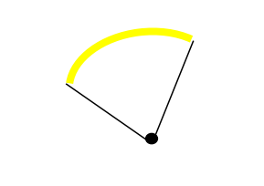

Figure 9-9 — Point Feature with Augmented geometries

More details can be found in the documentation of the drawing instruction model.

## Model of the Drawing Instruction Package

This package contains classes which describe the output of the portrayal functions. Display instructions link the feature types and their geometry to elements from the Symbol Elements package. The next diagram shows the model.

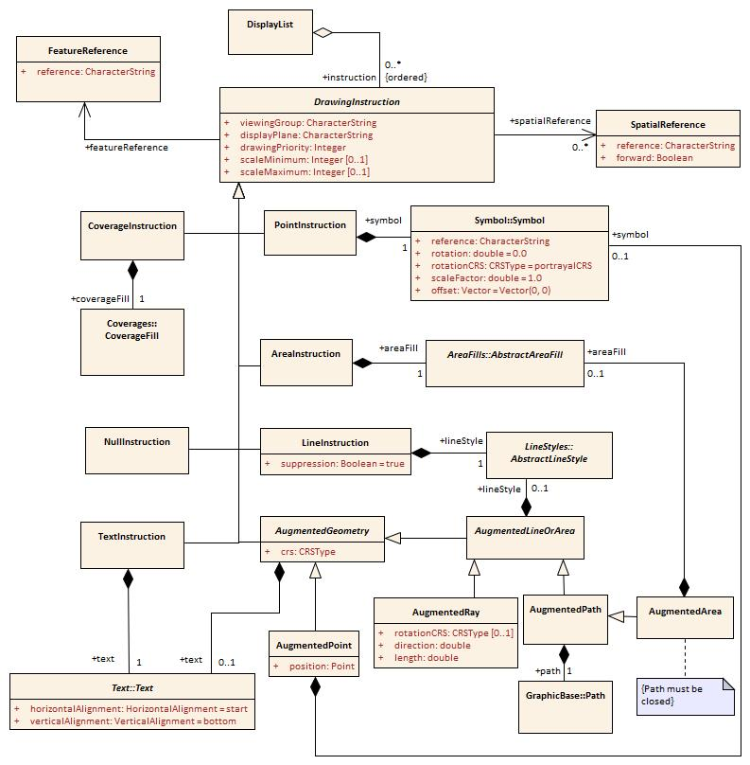

Figure 9-10 — Drawing Instructions

### DisplayList

|  |  |  |  |  |
| --- | --- | --- | --- | --- |
| **Role Name** | **Name** | **Description** | **Mult.** | **Type** |
| Class | DisplayList | A ordered set of Drawing Instructions | - | - |
| Role | instruction | An instruction of this list | 0..* | DrawingInstruction |

### DrawingInstruction

| **Role Name** | **Name** | **Description** | **Mult.** | **Type** |
| --- | --- | --- | --- | --- |
| Class | DrawingInstruction | Abstract base class for all drawing instructions | - | - |
| Attribute | viewingGroup | The viewing group the instruction is assigned to | 1 | string |
| Attribute | displayPlane | The display plane the instruction is assigned to | 1 | string |
| Attribute | drawingPriority | The priority that defines the order of drawing | 1 | integer |
| Attribute | scaleMinimum | Scale denominator to define the minimum scale for which the instruction will be shown. If not given there is no minimum scale | 0..1 | integer |
| Attribute | scaleMaximum | Scale denominator to define the maximum scale for which the instruction will be shown. If not given there is no maximum scale | 0..1 | integer |
| Role | featureReference | The reference to the feature type that will be depicted by the instruction | 1 | FeatureReference |
| Role | spatialReference | The reference(s) to the spatial type components of the feature that defines the geometry used for the depiction. Not used when the entire geometry of the feature should be depicted | 0..* | SpatialReference |
| Role | alertReference | The reference to the alert in the alert catalogue that is triggered by the geometry of the instruction | 0..1 | AlertReference |

### FeatureReference

|  |  |  |  |  |
| --- | --- | --- | --- | --- |
| **Role Name** | **Name** | **Description** | **Mult.** | **Type** |
| Class | FeatureReference | A reference to a feature type | - | - |
| Attribute | reference | The identifier of the feature type | 1 | string |

### SpatialReference

|  |  |  |  |  |
| --- | --- | --- | --- | --- |
| **Role Name** | **Name** | **Description** | **Mult.** | **Type** |
| Class | SpatialReference | A reference to a spatial type | - | - |
| Attribute | reference | The identifier of the spatial type | 1 | string |
| Attribute | forward | If true the spatial object is used in the direction in which it is stored in the data. Only applies to curves | 1 | boolean |

### AlertReference

|  |  |  |  |  |
| --- | --- | --- | --- | --- |
| **Role Name** | **Name** | **Description** | **Mult.** | **Type** |
| Class | AlertReference | A reference to an alert in the alert catalogue | - | - |
| Attribute | reference | The identifier of the alert catalogue entry | 1 | string |
| Attribute | plan | The viewing group the alert highlight is assigned to when active in route planning | 0..1 | string |
| Attribute | monitor | The viewing group the alert highlight is assigned to when active in route monitoring | 0..1 | string |

### NullInstruction

|  |  |  |  |  |
| --- | --- | --- | --- | --- |
| **Role Name** | **Name** | **Description** | **Mult.** | **Type** |
| Class | NullInstruction | An instruction that indicates that no portrayal is required for the referenced feature | - | - |

### PointInstruction

|  |  |  |  |  |
| --- | --- | --- | --- | --- |
| **Role Name** | **Name** | **Description** | **Mult.** | **Type** |
| Class | PointInstruction | A drawing instruction for point symbol | - | - |
| Role | symbol | The symbol to be depicted | 1 | Symbol::Symbol |

### LineInstruction

|  |  |  |  |  |
| --- | --- | --- | --- | --- |
| **Role Name** | **Name** | **Description** | **Mult.** | **Type** |
| Class | LineInstruction | A drawing instruction for line geometry | - | - |
| Attribute | suppression | Whether another line instruction of higher priority can suppress the drawing of this line instruction | 1 | boolean = *True* |
| Role | lineStyle | The line style used for the depiction | 1 | LineStyles::AbstractLineStyle |

### AreaInstruction

|  |  |  |  |  |
| --- | --- | --- | --- | --- |
| **Role Name** | **Name** | **Description** | **Mult.** | **Type** |
| Class | AreaInstruction | A drawing instruction for area geometry | - | - |
| Role | areaFill | The area fill used for the depiction | 1 | AreaFills::AbstractAreaFill |

### TextInstruction

|  |  |  |  |  |
| --- | --- | --- | --- | --- |
| **Role Name** | **Name** | **Description** | **Mult.** | **Type** |
| Class | TextInstruction | A drawing instruction for depicting text | - | - |
| Role | text | The text to be depicted | 1 | Text::Text |

### CoverageInstruction

|  |  |  |  |  |
| --- | --- | --- | --- | --- |
| **Role Name** | **Name** | **Description** | **Mult.** | **Type** |
| Class | CoverageInstruction | A drawing instruction for depicting coverages of data | - | - |
| Role | coverageFill | The coverage fill used for depiction | 1 | Coverages::CoverageFill |

### AugmentedGeometry

|  |  |  |  |  |
| --- | --- | --- | --- | --- |
| **Role Name** | **Name** | **Description** | **Mult.** | **Type** |
| Class | AugmentedGeometry | A base class for drawing instructions that uses geometry not available in the dataset. The geometry is generated by the portrayal functions according to a defined CRS | - | - |
| Attribute | crs | The coordinate reference system of the generated geometry. One of   * Geographic CRS * Portrayal CRS * Local CRS   For detailed description see the documentation of the GraphicsBase package | 1 | GraphicBase::CRSType |
| Role | text | A text to be depicted by the instruction. The rules for text apply depending on the type of geometry used by the instruction | 0..1 | Text::Text |

### AugmentedPoint

|  |  |  |  |  |
| --- | --- | --- | --- | --- |
| **Role Name** | **Name** | **Description** | **Mult.** | **Type** |
| Class | AugmentedPoint | A drawing instruction for a point symbol where the position is not given by the feature type | - | - |
| Attribute | position | The position of the symbol | 1 | GraphicBase::Point |
| Role | symbol | The symbol to be depicted | 0..1 | Symbol::Symbol |

### AugmentedLineOrArea

|  |  |  |  |  |
| --- | --- | --- | --- | --- |
| **Role Name** | **Name** | **Description** | **Mult.** | **Type** |
| Class | AugmentedLineOrArea | A base class for linear augmented geometry | - | - |
| Role | lineStyle | The line style to be depicted | 0..1 | LineStyles::LineStyle |

### AugmentedRay

|  |  |  |  |  |
| --- | --- | --- | --- | --- |
| **Role Name** | **Name** | **Description** | **Mult.** | **Type** |
| Class | AugmentedRay | A drawing instruction that defines a line from the position of a point feature to another position. The position is defined by the direction and the length attributes. It can be used for drawing line styles or line texts | - | - |
| Attribute | rotationCRS | If present, specifies the CRS for *direction* | 0..1 | GraphicsBase::CRSType |
| Attribute | direction | The direction of the ray relative to the used CRS | 1 | double |
| Attribute | length | The length of the ray. The units depending on the used CRS | 1 | double |

### AugmentedPath

|  |  |  |  |  |
| --- | --- | --- | --- | --- |
| **Role Name** | **Name** | **Description** | **Mult.** | **Type** |
| Class | AugmentedPath | A drawing instruction for a line. It can be used for drawing line styles or line texts | - | - |
| Role | path | The path defining the line geometry | 1 | GraphicsBase::Path |

### AugmentedArea

|  |  |  |  |  |
| --- | --- | --- | --- | --- |
| **Role Name** | **Name** | **Description** | **Mult.** | **Type** |
| Class | AugmentedArea | A drawing instruction for an area. It can be used for drawing line styles, area fills, or area texts. The used path must be closed | - | - |
| Role | areaFill | The area fill to be depicted | 0..1 | AreaFills::AreaFill |

For schema definition see A.3 Presentation Schema

# Symbol Definitions

## Overview

The SymbolDefinition package describes the graphic primitives used for the portrayal. Parts of the primitives are defined externally by using SVG definitions. Those external parts will be referenced from the types in this model. The package diagram is shown in the following figure.

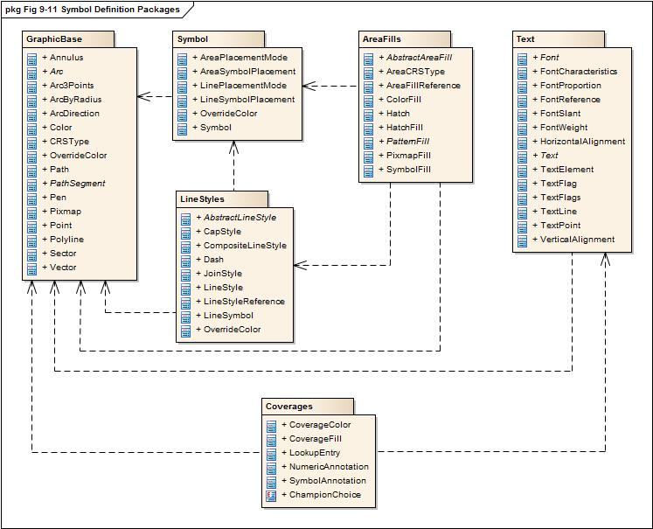

Figure 9-11 — Symbol Definition Packages

## The GraphicBase package

### Overview

This package contains graphic base types for the use in other packages.

### Model

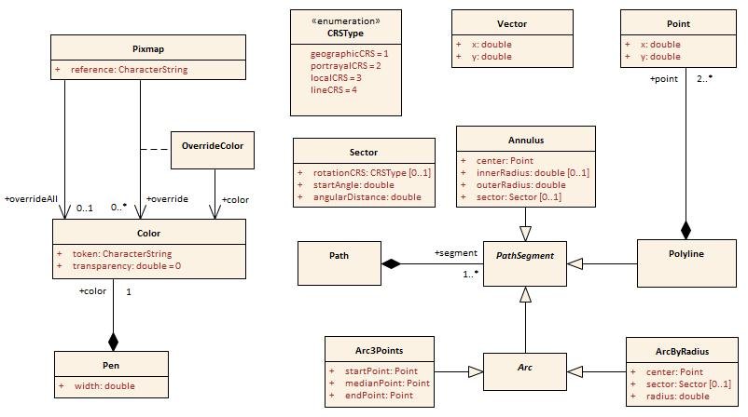

Figure 9-12 — Graphics Base

#### Point

|  |  |  |  |  |
| --- | --- | --- | --- | --- |
| **Role Name** | **Name** | **Description** | **Mult.** | **Type** |
| Class | Point | A zero-dimensional geometric object in a two-dimensional coordinate space. The coordinate will refer to a coordinate reference system | - | - |
| Attribute | x | The x-coordinate of the point. In case the CRS is a geographic CRS this refers to the longitude | 1 | double |
| Attribute | y | The y-coordinate of the point. In case the CRS is a geographic CRS this refers to the latitude | 1 | double |

#### Vector

|  |  |  |  |  |
| --- | --- | --- | --- | --- |
| **Role Name** | **Name** | **Description** | **Mult.** | **Type** |
| Class | Vector | A geometric object that has both a magnitude and a direction. It is limited to Cartesian coordinate reference systems | - | - |
| Attribute | x | The x-coordinate of the vector | 1 | double |
| Attribute | y | The y-coordinate of the vector | 1 | double |

#### Color

|  |  |  |  |  |
| --- | --- | --- | --- | --- |
| **Role Name** | **Name** | **Description** | **Mult.** | **Type** |
| Class | Color | Representing a colour according to the colour model | - | - |
| Attribute | token | The token specifies either an element in a colour table or a colour definition in the RGB space | 1 | string |
| Attribute | transparency | The value specifies the transparency; between 0 (opaque) and 1 (full transparent) | 1 | double |

#### Pen

|  |  |  |  |  |
| --- | --- | --- | --- | --- |
| **Role Name** | **Name** | **Description** | **Mult.** | **Type** |
| Class | Pen | A tool for drawing lines | - | - |
| Attribute | width | The width of the pen in mm | 1 | double |
| Role | color | The colour of the pen comprises the actual colour and the transparency | 1 | Color |

#### Pixmap

|  |  |  |  |  |
| --- | --- | --- | --- | --- |
| **Role Name** | **Name** | **Description** | **Mult.** | **Type** |
| Class | Pixmap | A two dimensional array of pixels defining an image | - | - |
| Attribute | reference | A reference to an external definition of the pixmap. This string is a unique identifier within the pixmap section of the portrayal catalogue | 1 | string |
| Role | overrideAll | A colour that override all none fully transparent colours used within the pixmap | 0..1 | Color |
| Association | override | A colour to be replaced by another colour | 0..* | OverrideColor |

#### OverrideColor

|  |  |  |  |  |
| --- | --- | --- | --- | --- |
| **Role Name** | **Name** | **Description** | **Mult.** | **Type** |
| Class | OverrideColor | Association class for the replacement of an existing colour in the pixmap with another colour | - | - |
| Role | color | The colour that is used to replace the existing colour in the pixmap | 1 | Color |

#### CRSType

|  |  |  |
| --- | --- | --- |
| **Role Name** | **Name** | **Description** |
| Type | CRSType | The value describes the type of a CRS. This includes the axes definitions, base line for angle measurement and units for distances |
| Enumeration | geographicCRS | A geographic CRS with axis latitude and longitude measured in degrees. Angles are defined clockwise from the true north direction. Distances will be measured in metres |
| Enumeration | portrayalCRS | A Cartesian coordinate system with the y-axis pointing upwards. Units on the axes and for distances are millimetres. Angles are measured in degrees clockwise from the positive y-axis.  Note that the actual output device may have a different orientation of the y-axis |
| Enumeration | localCRS | A Cartesian coordinate system originated at a local geometry. Units on the axes and for distances are millimetres. Angles are measured in degrees clockwise from the positive y-axis.  See explanations for details |
| Enumeration | lineCRS | A none-Cartesian coordinate system where the x-axis is following the geometry of a curve and the y-axis is perpendicular to the x-axis (positive to the left of the x-axis).  Units on the axes and for distances are millimetres. Angles are measured in degrees clockwise from the positive y-axis |

The following figure shows how the local CRS are defined for the different types of geometry.

From left to right:

* Local CRS for point geometry  
  Note: for multi points the local CRS is repeated at each point.
* Local CRS for curve geometry. The origin of the coordinate system can be any point of the line. This point can be defined by the absolute or relative distance from the start of the line. The x-axis is directed in the direction of the tangent at the tangency point and the y-axis is oriented perpendicular to this direction.
* Local CRS for surface geometry. For the boundary the same rules apply as for curve geometry. For the interior of the surface a coordinate system is used that has axes parallel to the Portrayal CRS. The origin can be an arbitrary point that is constant relative to the surface. This point can be outside the surface.

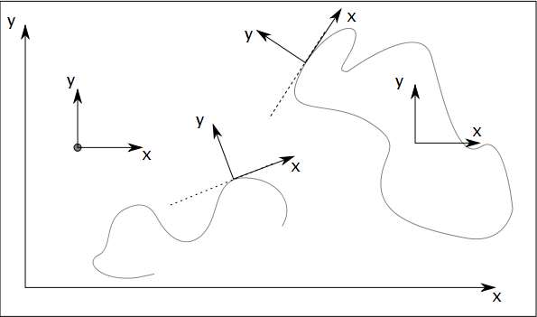

Figure 9-13 — Local CRS

X

Y

Y

Figure 9-14 — Line CRS

#### Sector

|  |  |  |  |  |
| --- | --- | --- | --- | --- |
| **Role Name** | **Name** | **Description** | **Mult.** | **Type** |
| Class | Sector | Region of the Cartesian plane enclosed by two radii | - | - |
| Attribute | rotationCRS | If present, specifies the CRS for startAngle | 0..1 | CRSType |
| Attribute | startAngle | The direction of the radius that defines the beginning of the sector | 1 | double |
| Attribute | angularDistance | The angular distance of the sector measured in degrees. Positive values means clockwise, negative values means anti-clockwise | 1 | double |

#### Path

|  |  |  |  |  |
| --- | --- | --- | --- | --- |
| **Role Name** | **Name** | **Description** | **Mult.** | **Type** |
| Class | Path | The definition of linear geometry by a composition of segments | - | - |
| Role | segment | The segments that build up the path | 1..* | PathSegment |

Paths can be closed or not closed. A closed path has coinciding start and end points. Segments are connected until a path is closed. In that case the next segment is not connected and the path contains multiple sub-paths.

#### PathSegment

|  |  |  |  |  |
| --- | --- | --- | --- | --- |
| **Role Name** | **Name** | **Description** | **Mult.** | **Type** |
| Class | PathSegment | Abstract base class for all segments that can be used within a path | - | - |

#### Polyline

|  |  |  |  |  |
| --- | --- | --- | --- | --- |
| **Role Name** | **Name** | **Description** | **Mult.** | **Type** |
| Class | Polyline | A segment defining its geometry by a series of points | - | - |
| Role | point | The segments the build up the path | 2..* | Point |

#### Arc

|  |  |  |  |  |
| --- | --- | --- | --- | --- |
| **Role Name** | **Name** | **Description** | **Mult.** | **Type** |
| Class | Arc | Abstract base class for segments describing arcs of a circle | - | - |

#### Arc3Points

| **Role Name** | **Name** | **Description** | **Mult.** | **Type** |
| --- | --- | --- | --- | --- |
| Class | Arc3Points | A segment describing an arc of a circle that is defined by 3 points. The points must not be colinear | - | - |
| Attribute | startPoint | The point where the arc starts | 1 | Point |
| Attribute | medianPoint | An arbitrary point on the arc | 1 | Point |
| Attribute | endPoint | The point where the arc ends | 1 | Point |

#### ArcByRadius

|  |  |  |  |  |
| --- | --- | --- | --- | --- |
| **Role Name** | **Name** | **Description** | **Mult.** | **Type** |
| Class | ArcByRadius | A segment describing an arc of a circle that is defined by the centre of the arc and a radius. Optional the arc can be restricted by a sector | - | - |
| Attribute | center | The centre of the arc | 1 | Point |
| Attribute | sector | The sector defining where the arc starts and end. If not present the arc is a full circle | 0..1 | Sector |
| Attribute | radius | The radius of the circle | 1 | double |

#### Annulus

|  |  |  |  |  |
| --- | --- | --- | --- | --- |
| **Role Name** | **Name** | **Description** | **Mult.** | **Type** |
| Class | Annulus | A ring-shaped region bounded by two concentric circles. Optional it can be enclosed by two radii of the circle | - | - |
| Attribute | center | The centre of the arc | 1 | Point |
| Attribute | innerRadius | The radius of the smaller circle. If not present the segment describes a sector of a circle | 0..1 | double |
| Attribute | outerRadius | The radius of the larger circle | 1 | double |
| Attribute | sector | The sector of an annulus segment | 0..1 | Sector |

## The Symbol package

### Model

This package contains the model of a symbol. Note that the definition of the symbol graphic itself is not the subject of this model. This will be defined in external files according to the SVG 1.1 recommendation.

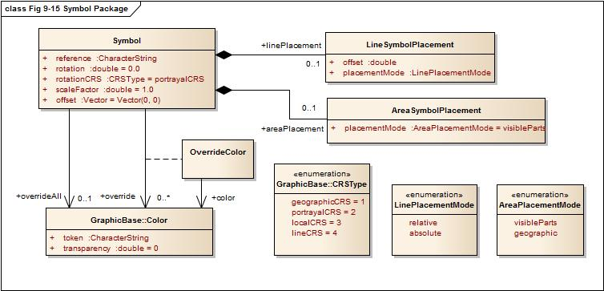

Figure 9-15 — Symbol Package

#### Symbol

|  |  |  |  |  |
| --- | --- | --- | --- | --- |
| **Role Name** | **Name** | **Description** | **Mult.** | **Type** |
| Class | Symbol | A two dimensional graphical element | - | - |
| Attribute | reference | A reference to an external definition of the symbol graphic. This is an unique identifier in the symbol section of the portrayal catalogue | 1 | string |
| Attribute | rotation | The rotation angle of the symbol. The default value is 0 | 1 | double |
| Attribute | rotationCRS | Specifies the coordinate reference system for the rotation | 1 | GraphicsBase::CRSType |
| Attribute | scaleFactor | The factor by which the original symbol graphic is scaled. The default value is 1 | 1 | double |
| Attribute | offset | The shift of the symbols position from the position of the geometry. The default value is the vector with length equals to 0 | 1 | GraphicsBase::Vector |
| Role | overrideAll | A colour that override all none fully transparent colours used within the symbol | 0..1 | GraphicsBase::Color |
| Association | override | A colour to be replaced by another colour | 0..* | OverrideColor |
| Role | linePlacement | Information where on a line the symbol should be placed | 0..1 | LineSymbolPlacement |
| Role | areaPlacement | Defines the placement of a symbol within an area | 0..1 | AreaSymbolPlacement |

#### OverrideColor

|  |  |  |  |  |
| --- | --- | --- | --- | --- |
| **Role Name** | **Name** | **Description** | **Mult.** | **Type** |
| Class | OverrideColor | Association class for the replacement of an existing colour in the symbol | - | - |
| Role | color | The colour that is used to replace an existing colour in the symbol | 1 | Color |

#### LineSymbolPlacement

|  |  |  |  |  |
| --- | --- | --- | --- | --- |
| **Role Name** | **Name** | **Description** | **Mult.** | **Type** |
| Class | LineSymbolPlacement | Defines the placement of a symbol along a line | - | - |
| Attribute | offset | The offset from the start of the curve | 1 | double |
| Attribute | placementMode | The mode that defines how the offset is to be interpreted | 1 | LinePlacementMode |

#### AreaSymbolPlacement

|  |  |  |  |  |
| --- | --- | --- | --- | --- |
| **Role Name** | **Name** | **Description** | **Mult.** | **Type** |
| Class | AreaSymbolPlacement | Defines the placement of a symbol within an area | - | - |
| Attribute | placementMode | The mode that defines how the symbol has to placed. | 1 | AreaPlacementMode |

#### LinePlacementMode

|  |  |  |
| --- | --- | --- |
| **Role Name** | **Name** | **Description** |
| Type | LinePlacementMode | Defines the type of placement of a symbol along a line |
| Enumeration | relative | The offset has to be interpreted as homogenous coordinates, 0 for the start and 1 for the end of the curve |
| Enumeration | absolute | The offset is the distance from the start of the curve |

#### AreaPlacementMode

|  |  |  |
| --- | --- | --- |
| **Role Name** | **Name** | **Description** |
| Type | AreaPlacementMode | Defines the type of placement of a symbol within an area |
| Enumeration | visibleParts | The symbol has to be placed at a representative position in each visible part of the surface |
| Enumeration | geographic | The symbol has to be placed at a representative position of the geographic object |

## The LineStyles package

### Model

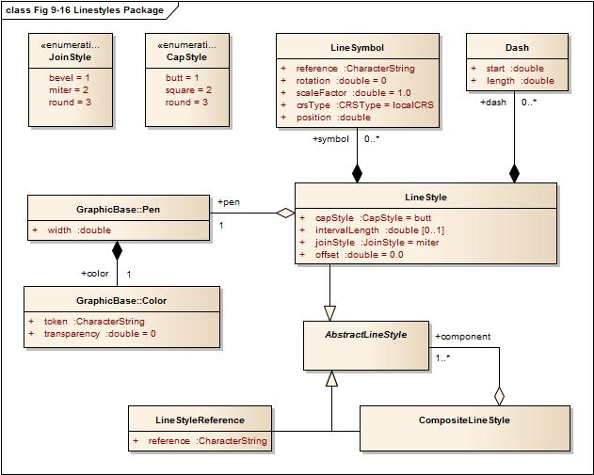

Figure 9-16 — Line Styles Package

#### AbstractLineStyle

|  |  |  |  |  |
| --- | --- | --- | --- | --- |
| **Role Name** | **Name** | **Description** | **Mult.** | **Type** |
| Class | AbstractLineStyle | Abstract base class for graphics to depict line geometry | - | - |

#### LineStyle

| **Role Name** | **Name** | **Description** | **Mult.** | **Type** |
| --- | --- | --- | --- | --- |
| Class | LineStyle | A style for line geometry either solid or dashed | - | - |
| Attribute | offset | An offset perpendicular to the direction of the line. The value refers to the y-axis of the line CRS (positive to the left, mm) | 1 | double |
| Attribute | capStyle | The decoration that is applied where a line segment ends | 1 | CapStyle |
| Attribute | joinStyle | The decoration that is applied where two line segments meet | 1 | JoinStyle |
| Attribute | intervalLength | The length of a repeating interval of the line style along the x-axis of the line CRS (units in mm) If not defined the line style describes a solid line | 0..1 | double |
| Role | dash | The dashes of a dashed line style | 0..* | Dash |
| Role | pen | The pen used for drawing the line | 1 | Pen |
| Role | symbol | Symbols placed along the line | 0..* | LineSymbol |

#### Dash

|  |  |  |  |  |
| --- | --- | --- | --- | --- |
| **Role Name** | **Name** | **Description** | **Mult.** | **Type** |
| Class | Dash | A single dash in a repeating line pattern | - | - |
| Attribute | start | The start of the dash measured from the start of the repeating interval,along the x-axis of the line CRS (units in mm) | 1 | double |
| Attribute | length | The length of the dash along the x-axis of the line CRS (units in mm) | 1 | double |

#### LineSymbol

|  |  |  |  |  |
| --- | --- | --- | --- | --- |
| **Role Name** | **Name** | **Description** | **Mult.** | **Type** |
| Class | LineSymbol | A symbol placed along a line in a repeating pattern | - | - |
| Attribute | reference | A reference to an external definition of the symbol graphic. This refers to an identifier of a catalogue item | 1 | string |
| Attribute | rotation | The rotation angle of the symbol. The default value is 0 | 1 | double |
| Attribute | scaleFactor | The scale factor of the symbol. The default is 1.0 | 1 | double |
| Attribute | crsType | The type of the CRS where the symbol has to be transformed to. Possible values are localCRS and lineCRS | 1 | CRSType |
| Attribute | position | The position of the symbol measured from the start of the repeating interval,along the x-axis of the line CRS (units in mm) | 1 | double |

#### CompositeLineStyle

|  |  |  |  |  |
| --- | --- | --- | --- | --- |
| **Role Name** | **Name** | **Description** | **Mult.** | **Type** |
| Class | CompositeLineStyle | A line style made with an aggregation of other line styles |  |  |
| Role | component | The components of the composite line style | 1..* | AbstractLineStyle |

#### LineStyleReference

|  |  |  |  |  |
| --- | --- | --- | --- | --- |
| **Role Name** | **Name** | **Description** | **Mult.** | **Type** |
| Class | LineStyleReference | A line style defined in an external file |  |  |
| Attribute | reference | The reference to the external definition of the line style. This is an unique identifier in the line style section of the Portrayal Catalogue | 1 | string |

#### JoinStyle

| **Role Name** | **Name** | **Description** |
| --- | --- | --- |
| Type | JoinStyle | The decoration that is applied where two line segments meet |
| Enumeration | bevel |  |
| Enumeration | miter |  |
| Enumeration | round |  |

#### CapStyle

|  |  |  |
| --- | --- | --- |
| **Role Name** | **Name** | **Description** |
| Type | CapStyle | The decoration that is applied where a line segment ends. |
| Enumeration | butt |  |
| Enumeration | square |  |
| Enumeration | round |  |

## The AreaFills package

### Model

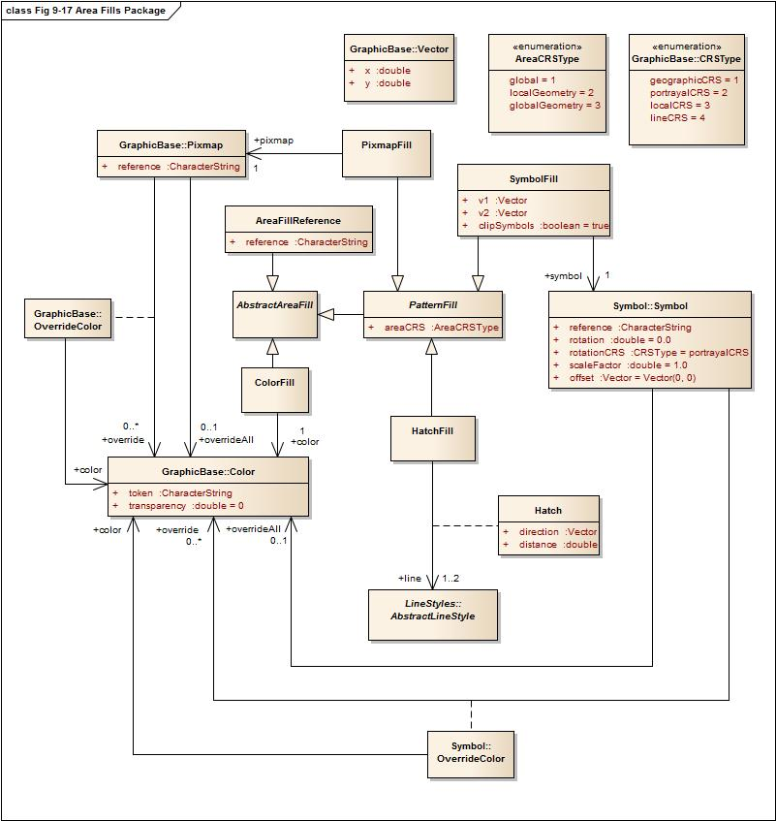

Figure 9-17 — Area Fills Package

#### AbstractAreaFill

|  |  |  |  |  |
| --- | --- | --- | --- | --- |
| **Role Name** | **Name** | **Description** | **Mult.** | **Type** |
| Class | AbstractAreaFill | Abstract base class for graphics that are designed to fill an area | - | - |

#### PatternFill

|  |  |  |  |  |
| --- | --- | --- | --- | --- |
| **Role Name** | **Name** | **Description** | **Mult.** | **Type** |
| Class | PatternFill | Abstract base class for pattern area fills | - | - |
| Attribute | areaCRS | Coordinate reference system which defines the origin of the pattern | 1 | AreaCRSType |

#### AreaFillReference

|  |  |  |  |  |
| --- | --- | --- | --- | --- |
| **Role Name** | **Name** | **Description** | **Mult.** | **Type** |
| Class | AreaFillReference | An area fill defined in an external file | - | - |
| Attribute | reference | The reference to the external definition. This is an unique identifier in the area fill section of the Portrayal Catalogue | 1 | string |

#### ColorFill

|  |  |  |  |  |
| --- | --- | --- | --- | --- |
| **Role Name** | **Name** | **Description** | **Mult.** | **Type** |
| Class | ColorFill | Class defining a solid colour fill for an area | - | - |
| Role | color | References the colour and transparency for the colour fill | 1 | Color |

#### PixmapFill

|  |  |  |  |  |
| --- | --- | --- | --- | --- |
| **Role Name** | **Name** | **Description** | **Mult.** | **Type** |
| Class | PixmapFill | Pattern fill where the pattern is defined by a pixmap | - | - |
| Role | pixmap | The pixmap defining the pattern | 1 | Pixmap |

#### SymbolFill

|  |  |  |  |  |
| --- | --- | --- | --- | --- |
| **Role Name** | **Name** | **Description** | **Mult.** | **Type** |
| Class | SymbolFill | Pattern fill where the pattern is defined by repeated symbols | - | - |
| Role | symbol | The symbol used for the pattern | 1 | Symbol |
| Attribute | v1 | Defines the offset of the next symbol in the first dimension of the pattern according to the local CRS | 1 | Vector |
| Attribute | v2 | Defines the offset of the next symbol in the second dimension of the pattern according to the local CRS | 1 | Vector |
| Attribute | clipSymbols | Indicates whether the symbols in the pattern are to be clipped by the area (when they are part in/out of the area) or whether the symbol is not drawn at all unless it is completely contained in the area | 1 | boolean  *True*: Fill symbols are clipped at area boundaries  *False*: Fill symbols extending over the area boundaries are not drawn at all |

#### HatchFill

|  |  |  |  |  |
| --- | --- | --- | --- | --- |
| **Role Name** | **Name** | **Description** | **Mult.** | **Type** |
| Class | HatchFill | Defining a pattern made of one or two sets of parallel lines | - | - |
| Association | Hatch | A set of parallel lines | 1 | Hatch |

#### Hatch

|  |  |  |  |  |
| --- | --- | --- | --- | --- |
| **Role Name** | **Name** | **Description** | **Mult.** | **Type** |
| Class | Hatch | A set of parallel lines used for an area fill pattern |  |  |
| Attribute | direction | The vector defining the direction of the set of lines | 1 | Vector |
| Attribute | distance | The distance between the lines measured perpendicular to the direction | 1 | double |
| Role | line | The line style used for each hatch line | 1..2 | LineStyles:: AbstractLineStyle |

#### AreaCRSType

|  |  |  |
| --- | --- | --- |
| **Role Name** | **Name** | **Description** |
| Type | PatternCRS | Describes how a fill patter is referenced |
| Enumeration | global | Anchor point is consistent with a location on the drawing device for, example starting with the corner of the screen. As screen pans the pattern will appear to shift/move through the object on screen |
| Enumeration | localGeometry | Anchor point is consistent with the local geometry of the object being depicted, for example the upper left corner of the object. Patterns of adjacent objects may not match |
| Enumeration | globalGeometry | The anchor point of the fill pattern is defined at a common location such that patterns remain consistent relative to all area objects |

## The Text package

### Overview

The text package contains the types necessary for the depiction of text. This includes fonts. In this model fonts may be described by characteristics or referenced by name. Two types of text instructions are supported:

* Text relative to a point
* Text that will be drawn along a linear geometry

### Fonts

A font is a set of typefaces. A typeface is the artistic representation or interpretation of characters; it is the way the type looks.

This standard supports two methods of defining fonts, the first describes a font by four attributes and let the system find a best match to an actual font available on the graphic system. The second method is referencing an external font file. The format of this file must conform to the ‘True Type Font’ standard and must be included in the the Portrayal Catalogue.

### Model

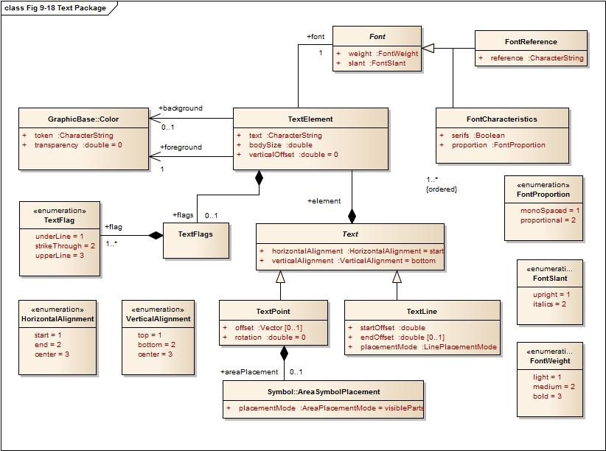

Figure 9-18 — Text Package

#### Font

|  |  |  |  |  |
| --- | --- | --- | --- | --- |
| **Role Name** | **Name** | **Description** | **Mult.** | **Type** |
| Class | Font | Abstract base class for fonts | - | - |

#### FontCharacteristics

|  |  |  |  |  |
| --- | --- | --- | --- | --- |
| **Role Name** | **Name** | **Description** | **Mult.** | **Type** |
| Class | FontCharacteristics | Class describing the main characteristics of a font | - | - |
| Attribute | serifs | Describes whether the typefaces contain serifs or not | 1 | boolean |
| Attribute | weight | Describes the thickness of the typefaces | 1 | FontWeight |
| Attribute | slant | Describes the slant of the typefaces | 1 | FontSlant |
| Attribute | proportion | Describes whether all typefaces in the font have an individual width or a fixed width | 1 | FontProportion |

#### FontReference

|  |  |  |  |  |
| --- | --- | --- | --- | --- |
| **Role Name** | **Name** | **Description** | **Mult.** | **Type** |
| Class | FontReference | Class referencing a font from an external source | - | - |
| Attribute | reference | The identifier for the external file within the portrayal catalogue | 1 | string |

#### Text

|  |  |  |  |  |
| --- | --- | --- | --- | --- |
| **Role Name** | **Name** | **Description** | **Mult.** | **Type** |
| Class | Text | The abstract base class of graphic elements for depicting text. The text is composed of elements | - | - |
| Attribute | horizontalAlignment | Specifies how the text is horizontally aligned relative to the anchor point. Default = start | 1 | HorizontalAlignment |
| Attribute | verticalAlignment | Specifies how the text is vertically aligned relative to the anchor point. Default = bottom | 1 | VerticalAlignment |
| Role | element | The ordered list of text elements | 1..* | TextElement |

#### TextPoint

|  |  |  |  |  |
| --- | --- | --- | --- | --- |
| **Role Name** | **Name** | **Description** | **Mult.** | **Type** |
| Class | TextPoint | A graphic element for depicting text relative to a point | - | - |
| Attribute | offset | Specifies the offset from the anchor point with respect to the portrayal CRS | 0..1 | GraphicsBase::Vector |
| Attribute | rotation | Specifies the rotation angle relative to the portrayal CRS. Default = 0 | 1 | double |
| Role | areaPlacement | Describes the placement of the text when the geometry is a surface | 0..1 | Symbol:: AreaSymbolPlacement |

#### TextLine

|  |  |  |  |  |
| --- | --- | --- | --- | --- |
| **Role Name** | **Name** | **Description** | **Mult.** | **Type** |
| Class | TextLine | A graphic element for depicting text along linear geometry | - | - |
| Attribute | startOffset | This offset specifies the anchor point on the line | 1 | double |
| Attribute | endOffset | This offset specifies the stop point of the text at the line. If present the startOffset does not specifies an anchor point but the start point of the text. The text will evenly be spaced between the two positions. Horizontal alignment has no effect in this case | 0..1 | double |
| Attribute | placementMode | Specifies how the offsets have to be interpreted | 1 | Symbol:: LinePlacementMode |

#### TextFlags

|  |  |  |  |  |
| --- | --- | --- | --- | --- |
| **Role Name** | **Name** | **Description** | **Mult.** | **Type** |
| Class | TextFlags | A container for text flags | - | - |
| Role | flag | A text flag | 1..* | TextFlag |

#### TextElement

|  |  |  |  |  |
| --- | --- | --- | --- | --- |
| **Role Name** | **Name** | **Description** | **Mult.** | **Type** |
| Class | TextElement | A sub element of a graphic text | - | - |
| Attribute | text | The text to be depicted | 1 | string |
| Attribute | bodySize | This property describes the size with which the text will be depicted | 1 | double |
| Attribute | verticalOffset | The vertical offset in mm between the base line of the text element and the base line of the text. This can be used to generate sub- or superscripts. Default = 0 | 1 | double |
| Role | flags | Flags describe special properties of the text element like underline etc. | 0..1 | TextFlags |
| Role | font | The font used for the depiction of the text element. | 1 | Font |
| Role | foreground | The colour used to depict the glyphs | 1 | Color |
| Role | background | The colour to fill the rectangle surrounding the text element before the text is depicted. If not given there is no fill (transparent) | 0..1 | Color |

#### FontSlant

|  |  |  |
| --- | --- | --- |
| **Role Name** | **Name** | **Description** |
| Type | FontSlant | The slant used within a font |
| Enumeration | upright | Typefaces are upright |
| Enumeration | italics | Typefaces are cursive |

#### FontWeight

|  |  |  |
| --- | --- | --- |
| **Role Name** | **Name** | **Description** |
| Type | FontWeigth | The thickness used for the typefaces in a font |
| Enumeration | light | Typefaces are depicted as thin (standard) |
| Enumeration | medium | Typefaces are depicted thicker as ‘Light’ but not as thin as ‘Bold’ |
| Enumeration | bold | Typefaces are depicted more prominent (**Bold**) |

#### FontProportion

|  |  |  |
| --- | --- | --- |
| **Role Name** | **Name** | **Description** |
| Type | FontProportion | The values describe how the width of the typefaces in a font is defined |
| Enumeration | monoSpaces | All typefaces in a font have the same width, also known as ‘typewriter’ fonts |
| Enumeration | proportional | Any typeface in the font as its individual width |

#### TextFlag

|  |  |  |
| --- | --- | --- |
| **Role Name** | **Name** | **Description** |
| Type | TextFlag | The values describe some effects used when the text will be depicted. The values can be combined |
| Enumeration | underLine | Text is depicted with a line under the text |
| Enumeration | strikeThrough | Text is depicted struck through, a line goes through the text |
| Enumeration | upperLine | Text is depicted with a line above the text |

#### VerticalAlignment

|  |  |  |
| --- | --- | --- |
| **Role Name** | **Name** | **Description** |
| Type | VerticalAlignment | Describes the text placement relative to the anchor point in vertical direction |
| Enumeration | top | The anchor point is at the top of the text |
| Enumeration | bottom | The anchor point is at the bottom of the text |
| Enumeration | center | The anchor point is at the (vertical) centre of the text |

#### HorizontalAlignment

|  |  |  |
| --- | --- | --- |
| **Role Name** | **Name** | **Description** |
| Type | HorizontalAlignment | Describes the text placement relative to the anchor point in horizontal direction |
| Enumeration | start | The anchor point is at the start of the text |
| Enumeration | end | The anchor point is at the end of the text |
| Enumeration | center | The anchor point is at the (horizontal) centre of the text |

## The Coverage package

### Overview

The coverage package contains the types for the depiction of a Coverage. This portrayal is applicable to the portrayal of numeric Coverage values. Three types of coverage portrayals are supported:

* Colour;
* Numeric Annotation; and
* Symbol Annotation.

### Ranges

Ranges are used to control how portrayal is assigned to the values in a Coverage. These make use of the S-100_NumericRange complex type which is defined in S-100 Part 1 Conceptual Schema Language. The Numeric Range type allows for various range definitions with different closure options.

### Lookup Table

The CoverageFill class carries an ordered list of lookup entries. Each of these entries carries a range used to evaluate a match by testing if the coverage value matches the range. The first lookup entry with a matching range is used to apply up to one of each type of portrayal (colour, numeric annotation or a symbol) to the coverage element. This allows for example to fill a cell in a grid with a colour and assign a numeric or symbol annotation to the cell as well.

The lookup table can also associate an alert specified in the drawing instruction with a range of coverage values. When associating alerts with coverage values there may or may not be portrayal elements (colour, numeric annotation or a symbol) present.

### Model

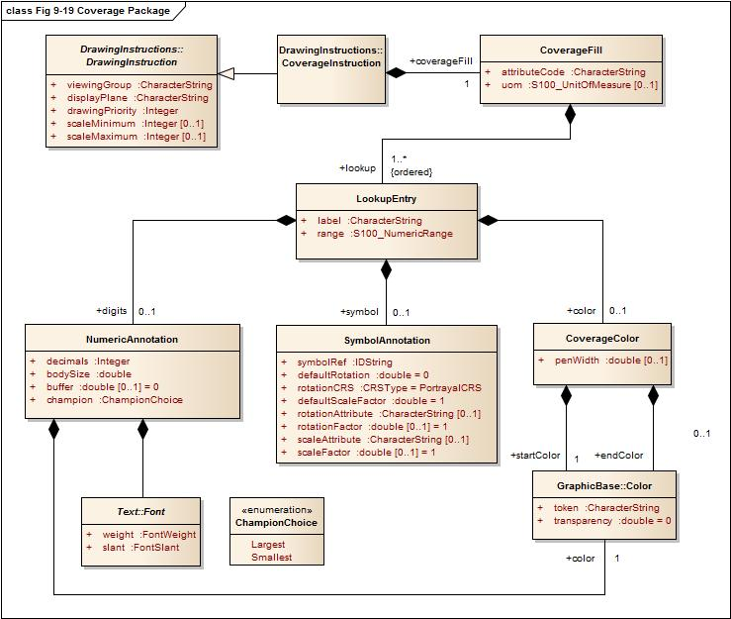

Figure 9-19 — Coverage Package

#### CoverageFill

|  |  |  |  |  |
| --- | --- | --- | --- | --- |
| **Role Name** | **Name** | **Description** | **Mult.** | **Type** |
| Class | CoverageFill | A class to fill a Coverage with using a lookup table to match a value or range of values and assign colour, numeric or symbol annotations | - | - |
| Attribute | attributeCode | Code of coverage attribute value to match | 1 | characterString |
| Attribute | uom | Unit of measure. If not given the values in the range are assumed to be same units as the coverage attribute values | 0..1 | S100_UnitOfMeasure |
| Role | lookup | Lookup table. The entries are ordered and processed on a first match basis | 1..* | LookupEntry |

#### LookupEntry

| **Role Name** | **Name** | **Description** | **Mult.** | **Type** |
| --- | --- | --- | --- | --- |
| Class | LookupEntry | An entry in a lookup table used to assign portrayal to coverage elements. | - | - |
| Attribute | label | String used as a display label or legend field. | 1 | characterString |
| Attribute | range | Value range definition. Can be a single value, open or closed range etc. See S-100 Part 1 Conceptual Schema Language for details. | 1 | S100_NumericRange |
| Role | color | The color to assign to the matching range. Can be a single color or a color ramp. | 0..1 | CoverageColor |
| Role | digits | Display the value as numeric digits. | 0..1 | NumericAnnotation |
| Role | symbol | Display a symbol. | 0..1 | SymbolAnnotation |

#### CoverageColor

|  |  |  |  |  |
| --- | --- | --- | --- | --- |
| **Role Name** | **Name** | **Description** | **Mult.** | **Type** |
| Class | CoverageColor | A class to fill a Coverage with color | - | - |
| Attribute | penWidth | Optional pen width to apply for dot color used for discrete points | 0..1 | double |
| Role | startColor | The color to assign to the matching range or to use as start point in a color ramp when ‘endColor’ is defined | 1 | GraphicBase::Color |
| Role | endColor | The color to use as stop point in a color ramp. The range of values is spread linearly across the range of colors from ‘startColor’ to ‘endColor’ to produce a gradient effect | 0..1 | GraphicBase::Color |

#### NumericAnnotation

|  |  |  |  |  |
| --- | --- | --- | --- | --- |
| **Role Name** | **Name** | **Description** | **Mult.** | **Type** |
| Class | NumericAnnotation | A class for numeric textual annotations of values in a Coverage | - | - |
| Attribute | decimals | Number of decimal digits to show in subscript | 1 | integer |
| Attribute | bodySize | This property describes the size with which the text will be depicted | 1 | double |
| Attribute | buffer | Buffer to apply for collision detection in presentation units. Default=0 | 1 | double |
| Attribute | champion | Enumeration to indicate which value to display in the event of a collision | 1 | ChampionChoice |
| Role | font | Font information to use for display of numeric values across a coverage. Text::Font is a choice of either FontCharacteristics or FontReference | 1 | Text::Font |
| Role | color | Color to draw the numeric annotation | 1 | GraphicBase::Color |

#### SymbolAnnotation

|  |  |  |  |  |
| --- | --- | --- | --- | --- |
| **Role Name** | **Name** | **Description** | **Mult.** | **Type** |
| Class | SymbolAnnotation | A class for symbol annotations of values in a coverage. | - | - |
| Attribute | symbolRef | Reference to the symbol to apply. Catalogue id. | 1 | IDString |
| Attribute | defaultRotation | A default symbol rotation. Applies when rotation attribute not defined. Default=0 | 0..1 | double |
| Attribute | rotationCRS | Specifies the coordinate reference system for the rotation. Default=PortrayalCRS | 1 | GraphicsBase::CRSType |
| Attribute | defaultScale | A default symbol scale factor. Applies when scale attribute not defined. Default=1 | 1 | double |
| Attribute | rotationAttribute | The attribute code of the Coverage Attribute to use for the symbol rotation value. | 0..1 | characterString |
| Attribute | rotationFactor | Used to adjust the ‘rotationAttribute’ value by multiplication before applying. Default 1.0 | 0..1 | double |
| Attribute | scaleAttribute | The attribute code of the Coverage attribute to use for scaling the symbol size. | 0..1 | characterString |
| Attribute | scaleFactor | Used to adjust the ‘ scaleAttribute’ value by multiplication before applying. Default 1.0 | 0..1 | double |

For schema definition see 9-A-2 Symbol Definition Schema

# The portrayal library

## Overview

* Machine readable.
* A file/directory structure with a catalogue file.
* Files for pixmaps, symbols, complex line styles, areafills, fonts and colour profiles.
* Alert information in a separate file.
* Portrayal rules in separate files.
* Model and schema for the catalogue included.

## Structure

Root ---- (contains the catalogue named “**portrayal_catalogue.xml**”, and optionally an alert catalogue file)

|

|-- Pixmaps (contains XML files describing pixmaps)

|

|-- ColorProfiles (contains XML files with colour profiles)

|

|-- Symbols (contains SVG files with symbols and CSS2 style sheets)

|

|-- LineStyles (contains XML files with line styles)

|

|-- AreaFills (contains XML files area fills)

|

|-- Fonts (contains TrueType font files)

|

|-- Rules (contains files with rules which map features to drawing instructions)

## Model of the Catalogue

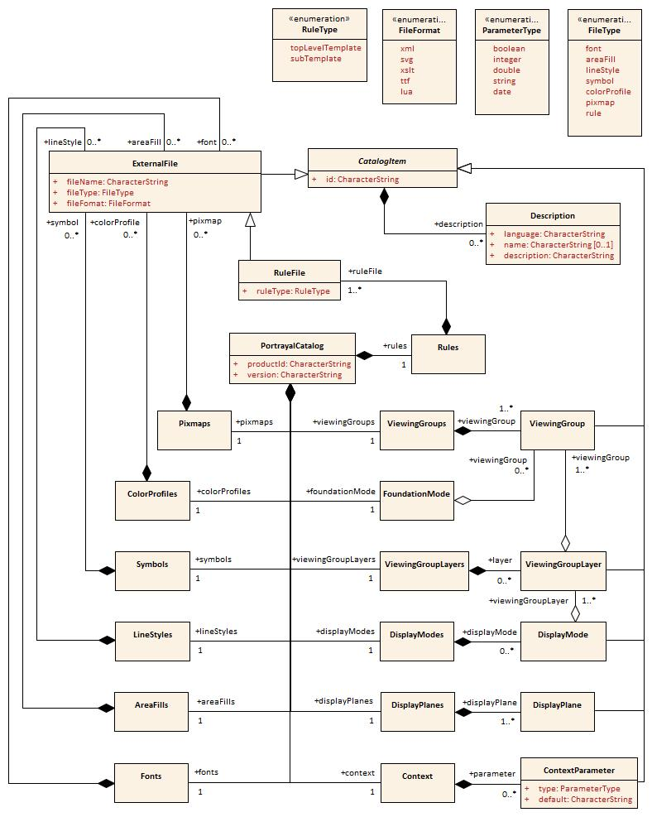

Figure 9-20 — Catalogue

### PortrayalCatalog

| **Role Name** | **Name** | **Description** | **Mult.** | **Type** |
| --- | --- | --- | --- | --- |
| Class | PortrayalCatalog | A container of all the Catalogue items | - | - |
| Attribute | productId | The ID of the product for which the Catalogue is intended | 1 | string |
| Attribute | version | The version of the product the Catalogue is defined for | 1 | string |
| Role | alertCatalog | A file reference to an alert catalogue | 0..1 | ExternalFile |
| Role | pixmaps | Container of XML Pixmap file references | 1 | Pixmaps |
| Role | colorProfiles | Container of XML Colour Profile file references | 1 | ColorProfiles |
| Role | symbols | Container of SVG Symbol file references | 1 | Symbols |
| Role | styleSheets | Container of CSS file references | 1 | StyleSheets |
| Role | lineStyles | Container of XML Line Style file references | 1 | LineStyles |
| Role | areaFills | Container of XML Area Fill file references | 1 | AreaFills |
| Role | fonts | Container of True Type font references | 1 | Fonts |
| Role | viewingGroups | Container of viewing group definitions | 1 | ViewingGroups |
| Role | foundationMode | The definition of the foundation of the portrayal | 1 | FoundationMode |
| Role | viewingGroupLayers | Container of viewing group layers. | 1 | ViewingGroupLayers |
| Role | displayModes | Container of display mode definitions | 1 | DisplayModes |
| Role | displayPlanes | Container of display plane definitions | 1 | DisplayPlanes |
| Role | context | Container of context parameter definitions | 1 | Context |
| Role | rules | Container of rule file references | 1 | Rules |

### CatalogItem

|  |  |  |  |  |
| --- | --- | --- | --- | --- |
| **Role Name** | **Name** | **Description** | **Mult.** | **Type** |
| Class | CatalogItem | An abstract base class for components of the Catalogue | - | - |
| Attribute | id | A unique identifier of the catalogue item | 1 | string |
| Role | description | Meta Data common to each Catalogue Item. There can be descriptions in different languages | 0..* | Description |

### ExternalFile

|  |  |  |  |  |
| --- | --- | --- | --- | --- |
| **Role Name** | **Name** | **Description** | **Mult.** | **Type** |
| Class | ExternalFile | A catalogue item that defines the reference to an external file | - | - |
| Subtype of | CatalogItem | See CatalogItem | - | - |
| Attribute | fileName | The name of the file | 1 | string |
| Attribute | fileType | The type of the file | 1 | FileType |
| Attribute | fileFormat | The format of the file | 1 | FileFormat |

### Description

|  |  |  |  |  |
| --- | --- | --- | --- | --- |
| **Role Name** | **Name** | **Description** | **Mult.** | **Type** |
| Class | Description | Language specific information about an item | - | - |
| Attribute | language | A language identifier code. ISO 639-2/T alpha-3 code (eng – English, fra – French, deu - German) | 1 | string |
| Attribute | name | An optional name of an item in the identified language | 0..1 | string |
| Attribute | description | The language specific description of the item | 1 | string |

### Pixmaps

|  |  |  |  |  |
| --- | --- | --- | --- | --- |
| **Role Name** | **Name** | **Description** | **Mult.** | **Type** |
| Class | Pixmaps | A container of pixmap file references | - | - |
| Role | pixmap | The file reference. The type is XML | 0..* | ExternalFile |

### ColorProfiles

|  |  |  |  |  |
| --- | --- | --- | --- | --- |
| **Role Name** | **Name** | **Description** | **Mult.** | **Type** |
| Class | ColorProfiles | A container of colour profile file references | - | - |
| Role | colorProfile | The file reference. The type is XML | 0..* | ExternalFile |

### Symbols

|  |  |  |  |  |
| --- | --- | --- | --- | --- |
| **Role Name** | **Name** | **Description** | **Mult.** | **Type** |
| Class | Symbols | A container of Symbol file references | - | - |
| Role | symbol | The file reference. The type is SVG | 0..* | ExternalFile |

### StyleSheets

|  |  |  |  |  |
| --- | --- | --- | --- | --- |
| **Role Name** | **Name** | **Description** | **Mult.** | **Type** |
| Class | StyleSheets | A container of CSS file references | - | - |
| Role | styleSheet | The file reference | 0..* | ExternalFile |

### LineStyles

|  |  |  |  |  |
| --- | --- | --- | --- | --- |
| **Role Name** | **Name** | **Description** | **Mult.** | **Type** |
| Class | LineStyles | A container of Line Style file references | - | - |
| Role | lineStyle | The file reference. The type is XML | 0..* | ExternalFile |

### AreaFills

|  |  |  |  |  |
| --- | --- | --- | --- | --- |
| **Role Name** | **Name** | **Description** | **Mult.** | **Type** |
| Class | AreaFills | A container of Area Fill file references | - | - |
| Role | lineStyle | The file reference. The type is XML. | 0..* | ExternalFile |

### Fonts

|  |  |  |  |  |
| --- | --- | --- | --- | --- |
| **Role Name** | **Name** | **Description** | **Mult.** | **Type** |
| Class | Fonts | A container for fonts | - | - |
| Role | font | The file reference. For true type fonts the type is ttf. | 0..* | ExternalFile |

### ViewingGroups

|  |  |  |  |  |
| --- | --- | --- | --- | --- |
| **Role Name** | **Name** | **Description** | **Mult.** | **Type** |
| Class | ViewingGroups | A container of Viewing Group definitions | - | - |
| Role | viewingGroup | Definition of a specific Viewing Group | 1..* | ViewingGroup |

### ViewingGroup

|  |  |  |  |  |
| --- | --- | --- | --- | --- |
| **Role Name** | **Name** | **Description** | **Mult.** | **Type** |
| Class | ViewingGroup | A Viewing Group name and definition | - | - |
| Subtype of | CatalogItem | See CatalogItem | - | - |

### FoundationMode

|  |  |  |  |  |
| --- | --- | --- | --- | --- |
| **Role Name** | **Name** | **Description** | **Mult.** | **Type** |
| Class | FoundationMode | A set of viewing groups that forms the foundation of the portrayal and cannot be removed from the display | - | - |
| Role | viewingGroup | Viewing group of the foundation mode | 0..* | ViewingGroup |

### ViewingGroupLayers

|  |  |  |  |  |
| --- | --- | --- | --- | --- |
| **Role Name** | **Name** | **Description** | **Mult.** | **Type** |
| Class | ViewingGroupLayers | A container of Viewing Group Layers | - | - |
| Role | layer | Definition of a specific Viewing Group layer | 0..* | ViewingGroupLayer |

### ViewingGroupLayer

|  |  |  |  |  |
| --- | --- | --- | --- | --- |
| **Role Name** | **Name** | **Description** | **Mult.** | **Type** |
| Class | ViewingGroupLayer | A set of Viewing groups which are intended to switch on or off in an application | - | - |
| Subtype of | CatalogItem | See CatalogItem | - | - |
| Role | viewingGroup | Viewing Group of the layer | 1..* | ViewingGroup |

### DisplayModes

|  |  |  |  |  |
| --- | --- | --- | --- | --- |
| **Role Name** | **Name** | **Description** | **Mult.** | **Type** |
| Class | DisplayModes | A container of Display Mode definitions | - | - |
| Role | displayMode | Definition of a Display Mode | 1..* | DisplayMode |

### DisplayMode

|  |  |  |  |  |
| --- | --- | --- | --- | --- |
| **Role Name** | **Name** | **Description** | **Mult.** | **Type** |
| Class | DisplayMode | A set of Viewing Layers to switch on or off in an application | - | - |
| Subtype of | CatalogItem | See CatalogItem | - | - |
| Role | viewingGroupLayer | Viewing Group Layer included in this Display Mode | 1..* | ViewingGroupLayer |

### DisplayPlanes

|  |  |  |  |  |
| --- | --- | --- | --- | --- |
| **Role Name** | **Name** | **Description** | **Mult.** | **Type** |
| Class | DisplayPlanes | A container of Display Plane definitions | - | - |
| Role | displayPlane | Definition of a Display Plane | 1..* | DisplayPlane |

### DisplayPlane

|  |  |  |  |  |
| --- | --- | --- | --- | --- |
| **Role Name** | **Name** | **Description** | **Mult.** | **Type** |
| Class | DisplayPlane | A Display Plane name and definition | - | - |
| Subtype of | CatalogItem | See CatalogItem | - | - |
| Attribute | order | Used to sort the drawing order of display planes. Display planes with larger values are drawn above those with lower values  Positive: Above RADAR  Zero: Reserved for RADAR  Negative: Below RADAR | 1 | integer |

### Context

|  |  |  |  |  |
| --- | --- | --- | --- | --- |
| **Role Name** | **Name** | **Description** | **Mult.** | **Type** |
| Class | Context | A container of Context Parameters | - | - |
| Role | parameter | Context Parameter | 0..* | ContextParameter |

### ContextParameter

| **Role Name** | **Name** | **Description** | **Mult.** | **Type** |
| --- | --- | --- | --- | --- |
| Class | ContextParameter | A Context Parameter name and definition | - | - |
| Subtype of | CatalogItem | See CatalogItem | - | - |
| Attribute | type | The data type of the Parameter | 1 | ParameterType |
| Attribute | default | A default value for the Parameter | 1 | string |

### Rules

|  |  |  |  |  |
| --- | --- | --- | --- | --- |
| **Role Name** | **Name** | **Description** | **Mult.** | **Type** |
| Class | Rules | A container of XSLT rule file references | - | - |
| Role | ruleFile | Reference to a file containing rules | 1..* | RuleFile |

### RuleFile

|  |  |  |  |  |
| --- | --- | --- | --- | --- |
| **Role Name** | **Name** | **Description** | **Mult.** | **Type** |
| Class | RuleFile | Rule file reference | - | - |
| Subtype of | ExternalFile | See ExternalFile | - | - |
| Attribute | ruleType | The type of the templates within the rule file. There can be more than one top level rule which can be selected in an application to allow different portrayal of the data | 1 | RuleType |

### ParameterType

|  |  |  |
| --- | --- | --- |
| **Role Name** | **Name** | **Description** |
| Type | ParameterType | Choice of Parameter Types |
| Enumeration | boolean | A Boolean value |
| Enumeration | integer | An integer number |
| Enumeration | double | A floating point number |
| Enumeration | string | A character string |
| Enumeration | date | A date according to the gregorian calendar |

### FileFormat

|  |  |  |
| --- | --- | --- |
| **Role Name** | **Name** | **Description** |
| Type | FileFormat | The format of an external file |
| Enumeration | xml |  |
| Enumeration | svg |  |
| Enumeration | xslt |  |
| Enumeration | ttf |  |
| Enumeration | lua |  |
| Enumeration | css |  |

### FileType

| **Role Name** | **Name** | **Description** |
| --- | --- | --- |
| Type | FileType | The type of an external file |
| Enumeration | font | A font file |
| Enumeration | areaFill | A file describing an area fill |
| Enumeration | lineStyle | A file describing a line style |
| Enumeration | symbol | A file describing a symbol |
| Enumeration | colorProfile | A file describing a colour profile |
| Enumeration | pixmap | A file describing a pixmap |
| Enumeration | rules | A file containing portrayal rules |
| Enumeration | styleSheet | A file containing styles for symbols |
| Enumeration | alertCatalog | A file containing an alert catalogue |

### RuleType

|  |  |  |
| --- | --- | --- |
| **Role Name** | **Name** | **Description** |
| Type | RuleType | The type of templates within a rule file |
| Enumeration | topLevelTemplate | The rule file contains a top level template |
| Enumeration | subTemplate | The rule file contains templates that are used or called by other templates |

For schema definition see 9-A-5 Portrayal Catalogue Schema

## Model of the alert catalogue

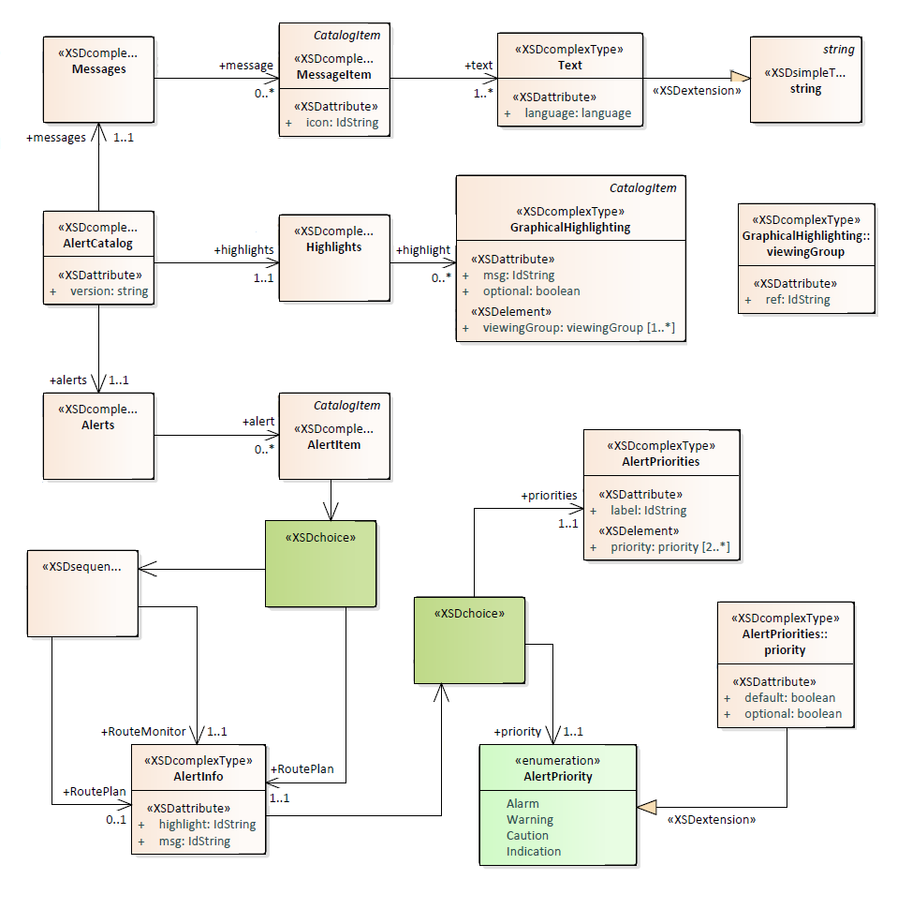

Figure 9-21 — Alert Catalogue

### AlertCatalog

|  |  |  |  |  |
| --- | --- | --- | --- | --- |
| **Role Name** | **Name** | **Description** | **Mult.** | **Type** |
| Class | AlertCatalog | A container of all the Catalogue items | - | - |
| Attribute | version | The version of the catalogue | 1 | string |
| Role | messages | Container of messages | 1 | Messages |
| Role | highlights | Container of highlights | 1 | Highlights |
| Role | alerts | Container of alerts | 1 | Alerts |

### Messages

|  |  |  |  |  |
| --- | --- | --- | --- | --- |
| **Role Name** | **Name** | **Description** | **Mult.** | **Type** |
| Class | Messages | A container of MessageItems | - | - |
| Role | message | Definition of a message | 0..* | MessageItem |

### MessageItem

|  |  |  |  |  |
| --- | --- | --- | --- | --- |
| **Role Name** | **Name** | **Description** | **Mult.** | **Type** |
| Class | MessageItem | Defines a language independent message | - | - |
| Subtype of | CatalogItem | See CatalogItem | - | - |
| Attribute | icon | Reference to a symbol in the portrayal catalogue | 0..1 | string |
| Role | text | Language specific text | 1..* | Text |

### Text

|  |  |  |  |  |
| --- | --- | --- | --- | --- |
| **Role Name** | **Name** | **Description** | **Mult.** | **Type** |
| Class | Text | Language specific string | - | - |
| Subtype of | string |  | - | - |
| Attribute | language | Identifies a language, default is eng. ISO 639-2/T alpha-3 code (eng – English, deu – German) | 0..1 | string |

### Highlights

|  |  |  |  |  |
| --- | --- | --- | --- | --- |
| **Role Name** | **Name** | **Description** | **Mult.** | **Type** |
| Class | Highlights | A container of GraphicalHighlighting items | - | - |
| Role | highlight | Definition of a highlight | 0..* | GraphicalHighlighting |

### GraphicalHighlighting

|  |  |  |  |  |
| --- | --- | --- | --- | --- |
| **Role Name** | **Name** | **Description** | **Mult.** | **Type** |
| Class | GraphicalHighlighting | Associates viewing groups with alert information | - | - |
| Subtype of | CatalogItem | See CatalogItem | - | - |
| Attribute | optional | Allowing the highlight to be turned off is not required. Default is false | 0..1 | boolean |
| Attribute | msg | A reference to a message to be displayed while any of the viewing groups are disabled | 0..1 | string |
| Role | viewingGroup | References viewing groups used to control graphical highlighting | 1..* | ViewingGroupReference |

### ViewingGroupReference

|  |  |  |  |  |
| --- | --- | --- | --- | --- |
| **Role Name** | **Name** | **Description** | **Mult.** | **Type** |
| Class | ViewingGroupReference | A reference to a viewing group | - | - |
| Role | ref | The identifier of the viewing group | 1 | string |

### Alerts

|  |  |  |  |  |
| --- | --- | --- | --- | --- |
| **Role Name** | **Name** | **Description** | **Mult.** | **Type** |
| Class | Alerts | A container of AlertItems | - | - |
| Role | alert | Definition of an alert | 0..* | AlertItem |

### AlertItem

|  |  |  |  |  |
| --- | --- | --- | --- | --- |
| **Role Name** | **Name** | **Description** | **Mult.** | **Type** |
| Class | AlertItem | Describes a single alert | - | - |
| Subtype of | CatalogItem | See CatalogItem | - | - |
| Role | routeMonitor | The alert behavior in route monitoring | 0..1 | AlertInfo |
| Role | routePlan | The alert behavior in route planning | 0..1 | AlertInfo |

### AlertInfo

|  |  |  |  |  |
| --- | --- | --- | --- | --- |
| **Role Name** | **Name** | **Description** | **Mult.** | **Type** |
| Class | AlertInfo | The behavior of an alert in a single mode | - | - |
| Attribute | routeMonitor | The alert behavior in route monitoring | 0..1 | AlertInfo |
| Attribute | routePlan | The alert behavior in route planning | 0..1 | AlertInfo |
| Role | priority | A single alert priority. If present, precludes use of *priorities* | 0..1 | AlertPriority |
| Role | priorities | A set of alert priorities. If present, precludes use of *priority* | 0..1 | AlertPriorities |

### AlertPriorities

|  |  |  |  |  |
| --- | --- | --- | --- | --- |
| **Role Name** | **Name** | **Description** | **Mult.** | **Type** |
| Class | AlertPriorities | A set of alert priorities | - | - |
| Attribute | label | Reference to a message used to label the UI component which allows selection of the desired alert priority | 1 | string |
| Role | priority | An alert priority | 2..* | AlerPrioritySelection |

### AlertPrioritySelection

|  |  |  |  |  |
| --- | --- | --- | --- | --- |
| **Role Name** | **Name** | **Description** | **Mult.** | **Type** |
| Class | AlertPrioritySelection | Adds information to an alert priority | - | - |
| Subtype of | AlertPriority | See AlertPriority | - | - |
| Attribute | default | Identifies the default priority selection. Default is false | 0..1 | boolean |
| Attribute | optional | Indicates allowing the user to choose this priority is optional. Default is false | 0..1 | boolean |

### AlertPriority

| **Role Name** | **Name** | **Description** |
| --- | --- | --- |
| Type | AlertPriority | The priority of an alert |
| Enumeration | Alarm | Indicates conditions requiring immediate attention and action by the bridge team (refer to MSC.252(83) 19.1.2) |
| Enumeration | Warning | Indicates changed conditions and should be presented for precautionary reasons which are not immediately hazardous but which may become so, if no action is taken (refer to MSC.252(83) 19.1.3) |
| Enumeration | Caution | Indicates a condition which does not warrant an alarm or warning condition, but still requires attention and out of the ordinary consideration of the situation or of given information (refer to MSC.252(83) 19.1.4) |
| Enumeration | Indication | Display of regular information and conditions (refer to MSC.252(83) appendix 1) |

## Schema for pixmap files

A pixmap is a two dimensional array of pixels defining an image. This schema allows to encode pixmaps that can be then be referenced, for example from pixmap area fills. The coordinate system for the pixmap is different than other coordinate systems in this standard. The y-axis is directed downwards and the origin is in the upper left corner of the pixmap.

Figure 9-22 — Coordinate system for pixmap

The graphic above shows a simple pixmap with width 10 pixel and height 9 pixel. Most of the pixels are transparent (here white) some pixels are coloured.

The style defines a simple type for the colour identifier:

<xs:simpleType name="ColorId">  
 <xs:restriction base="xs:string">  
 <xs:minLength value="1"></xs:minLength>  
 <xs:maxLength value="3"></xs:maxLength>  
 <xs:pattern value="[a-zA-Z0-9_]+"></xs:pattern>  
 </xs:restriction>  
 </xs:simpleType>

This describes a token 1 to 3 characters long that can contain digits, alpha characters or the underscore. It is used to identifiy a colour in the colour map.

The next type is a complex type for a pixel:

<xs:complexType name="Pixel">  
 <xs:simpleContent>  
 <xs:extension base="ColorId">  
 <xs:attribute name="x" type="xs:nonNegativeInteger" use="required"/>  
 <xs:attribute name="y" type="xs:nonNegativeInteger" use="required"/>  
 </xs:extension>  
 </xs:simpleContent>  
</xs:complexType>

It extends the colour identifier and adds two attributes for the coordinate of the pixel according to the pixmap coordinate system.

Each pixmap contains a colour map; a list of colour definitions bundled with a colour identifier. Two types are defined in the schema one for the colour map item and one for the colour map.

<xs:complexType name="ColorMapItem">  
 <xs:complexContent>  
 <xs:extension base="s100Symbol:Color">  
 <xs:attribute name="id" type="ColorId" use="required"/>  
 </xs:extension>  
 </xs:complexContent>  
</xs:complexType>  
  
<xs:complexType name="ColorMap">  
 <xs:sequence>  
 <xs:element name="color" type="ColorMapItem" minOccurs="1" maxOccurs="unbounded"/>  
 </xs:sequence>  
</xs:complexType>

Note: The color definition is taken from the S-100 symbol definition schema. That allows using colour token from a colour profile or direct sRGB colour definitions. Transparency can be defined here as well.

The last type defined is the complex type for the pixmap itself.

<xs:complexType name="Pixmap">  
 <xs:sequence>  
 <xs:element name="description" type="xs:string" minOccurs="0" maxOccurs="1"/>  
 <xs:element name="width" type="xs:positiveInteger"/>  
 <xs:element name="height" type="xs:positiveInteger"/>  
 <xs:element name="colorMap" type="ColorMap">  
 <xs:key name="colorKey">  
 <xs:selector xpath="color"/>  
 <xs:field xpath="@id"/>  
 </xs:key>   
 </xs:element>   
 <xs:element name="background" type="ColorId"/>  
 <xs:element name="pixel" type="Pixel" minOccurs="0" maxOccurs="unbounded"/>  
 </xs:sequence>  
</xs:complexType>

It defines an optional description element and mandatory elements for width and height. Furthermore it defines an element for the colour map, an element for the background colour and the any number of pixel elements. The background colour is implicitly used for all pixels that are not defined by a pixel element. Note that there is a key element to ensure that colour identifiers are unique.

Finally the root element is defined:

<xs:element name="pixmap" type="Pixmap">  
 <xs:keyref refer="colorKey" name="pixelRef">  
 <xs:selector xpath="pixel"/>  
 <xs:field xpath="."/>  
 </xs:keyref>  
 <xs:keyref refer="colorKey" name="backgroundRef">  
 <xs:selector xpath="background"/>  
 <xs:field xpath="."/>  
 </xs:keyref>  
 <xs:unique name="positionUnique">  
 <xs:selector xpath="pixel"/>  
 <xs:field xpath="@x"/>  
 <xs:field xpath="@y"/>  
 </xs:unique>  
</xs:element>

The keyref element are there for ensure the referential integrity of the colour identifier used in the pixel and background element. The unique element ensures that no pixel is defined more than ones.

A complete pixmap file for the example above looks like:

<?xml version="1.0" encoding="UTF-8"?>  
<pixmap xmlns:xsi="http://www.w3.org/2001/XMLSchema-instance"  
 xsi:noNamespaceSchemaLocation="S100Pixmap.xsd">  
 <description>Test pixmap showing a capital H in faint magenta.</description>  
 <width>10</width>  
 <height>9</height>  
 <colorMap>  
 <color id="_" transparency="1.0">#000000</color>  
 <color id="M">#8F83B6</color>  
 </colorMap>  
 <background>_</background>  
 <pixel x="3" y="2">M</pixel>  
 <pixel x="3" y="3">M</pixel>  
 <pixel x="3" y="4">M</pixel>  
 <pixel x="3" y="5">M</pixel>  
 <pixel x="3" y="6">M</pixel>  
 <pixel x="4" y="4">M</pixel>  
 <pixel x="5" y="4">M</pixel>  
 <pixel x="6" y="2">M</pixel>  
 <pixel x="6" y="3">M</pixel>  
 <pixel x="6" y="4">M</pixel>  
 <pixel x="6" y="5">M</pixel>  
 <pixel x="6" y="6">M</pixel>  
</pixmap>

# Appendix 9-A Generating Portrayal Input XML (informative)

## Preface

This standard describes a base schema that contains base types which define the expected structure of the XML input to the portrayal processing. The XSLT portrayal rules expect the input XML to conform with the base schema, with additional information as defined within a products feature catalogue.

Although the encoded elements of the input XML must conform to the base schema, it is not necessary to fully describe a schema for each products input XML. It is sufficient that the portrayal rules can consistently parse the input XML using XPath 1.0 queries.

The base schema should be used along with patterns described in this Annex to model a generic pattern for describing all S-100 content; essentially providing a mapping from the S-100 general feature model to an XML encoding of an instance of the model.

This section describes how the input XML should be generated. Patterns will be introduced to map the data model from a feature catalogue to an input XML for portrayal. Although the input XML can cover the entire data model it is sufficient to generate only the part that is relevant for portrayal.

## Input XML structure

The input XML must conform to the following structure, using the indicated element names and order.

<!—The root element -->

<Dataset>

<InformationTypes>

</InformationTypes>

<!—Spatial Objects -->

<Points>

</Points>

<MultiPoints>

</MultiPoints>

<Curves>

</Curves>

<CompositeCurves>

</CompositeCurves>

<Surfaces>

</Surfaces>

<Features>

</Features>

</Dataset>

## Simple attributes

When encoding simple attributes the element name should match the code of a simple attribute defined within the product feature catalogue. For enumerations, the code should be passed as the value, the label should not be used.

<colour>3</colour> <!—don’t encode as red -->

## Complex attributes

When encoding complex attributes the element name should match the code of a complex attribute defined within the product feature catalogue. Simple and/or complex sub attributes should be nested within the element.

An instance of complex attribute „speed“ with simple sub attributes „speedMaximum“ and „speedMinimum“:

<speed>  
 <speedMaximum>10</speedMaximum>  
 <speedMinimum>0</ speedMinimum>  
 </speed>

## Information types

Instances of information types are encoded within the *<InformationTypes>* section of the input XML. Information types are referenced by other objects encoded in the input XML.

The base schema defines abstract type *Information* for encoding of information types. The following pattern describes instantiation of the abstract type:

* The element name of each information type object must match the code of an InformationType defined in the product feature catalogue. The code defines the instantiation of the abstract type; in the example below, ChartNote is the instantiation of *Information*.
* The value(s) of the attributes of the information type should be included in the encoding, as described in 9-A-2 and 9-A-3. These values should be nested within the element described by the preceding bullet (they are part of the instantiation).

Notional information type ChartNote, described in the feature catalogue as having complex attribute *note*, which has simple sub attributes *noteText* and *language*:

<ChartNote id="I1">  
 <note>  
 <noteText>Hello world!</noteText>  
 <language>en</language>  
 </note>  
 <note>  
 <noteText>Hallo Welt!</noteText>  
 <language>de</language>  
 </note>  
 </ChartNote>

## Spatial Objects

The base schema defines spatial types which describe XML encodings of the Part 7 Spatial Schema. These types provide a consistent way to represent spatial objects to the portrayal processing. The input XML encoding of spatial objects should conform with the base schema; the spatial model cannot be modified by a product feature catalogue.

In most cases the portrayal rules do not attempt to reference the geometry coordinates of spatial objects; in these cases the geometry coordinates may be omitted from the input XML, potentially providing significant advantages to the speed of generating and parsing the input XML. A notable exception when the geometry coordinates cannot be omitted: symbolization of MultiPoint spatial objects. Geometry coordinates should always be provided for MultiPoint spatial objects.

## Features

Instances of feature types are encoded within the *<Features>* section of the input XML.

The base schema defines abstract type *Feature* for encoding of feature objects. The following pattern describes instantiation of the abstract type:

* The element name of each feature object must match the code of a feature type defined in the product feature catalogue. The code defines the instantiation of the abstract type; in the example below, BeaconLateral is the instantiation of *Feature*.
* The value(s) of the attributes of the feature object should normally be included in the encoding, as described in 9-A-2 and 9-A-3. These values should be nested within the element described by the preceding bullet (they are part of the instantiation). Attribute values provided via Coverages should be omitted from the encoding.
* All references to spatial objects should be included as described in the base schema.
* All associations to information type instances and feature instances should be included, as described in 9-A-7.

An example encoding of an instance of a BeaconLateral feature. The feature references a spatial object of type Point (P23), and has an association to a feature instance (F8) which should also be described in the input XML, but is not shown in this example. The value of each of the features attributes is also encoded.

<BeaconLateral id="F4" primitive=”Point” >

<Point ref="P23" scaleMinimum=“4294967295” scaleMaximum=”0” />

<beaconShape>1</beaconShape>

<categoryOfLateralMark>2</categoryOfLateralMark>

<colour>3</colour>

<reportedDate>20050124</reportedDate>

<status>1</status>

<scaleMinimum>89999</scaleMinimum>

<StructureEquipment role=”supports” featureRef=”F8” />

</BeaconLateral>

## Associations

Associations are named relationships between objects. There are two types of associations: information associations for relationships between any object and an information type, and feature associations for relationships between two feature types.

The base schema provides element *associatedInformationCode* as part of both feature objects and spatial objects, and provides element *associatedFeatureCode* as part of feature objects. The pattern for encoding associations is:

* The element name of each association must match the code of an association defined in the product feature catalogue. The code describes the subtype of the association; in the example below, StructureEquipment replaces *associatedFeatureCode* from the base schema and describes the relationship between the two feature objects.
* The value of the *role* attribute should match a role described in the feature catalogue.
* The value of *featureRef* (for feature associations) or *informationRef* (for information associations) should match the unique id of a feature instance or information type instance encoded within the input XML.
* Include the values of any simple or complex attributes which are defined for the association as described in the feature catalogue. These values should be nested within the association element.

An example feature association: *StructureEquipment*. The association should be nested within the encoding of a feature instance.

<Features>

<FeatureTypeX id="F1" primitive=”Point” >

<!-- feature attributes and spatial reference omitted -->

<StructureEquipment role=”supports” featureRef=”F2”/>

</FeatureTypeX>

<FeatureTypeY id="F2" primitive=”Point” >

<!-- feature attributes and spatial reference omitted -->

<StructureEquipment role=”supportedBy” featureRef=”F1” />

</FeatureTypeY>

</Features>

An example information association: An instance of a *SpatialQuality* information type referenced from a spatial object using a *SpatialAssociation* InformationAssociation type:

<InformationTypes>

<SpatialQuality id="I1">

<qualityOfHorizontalMeasurement>4</qualityOfHorizontalMeasurement>

</SpatialQuality>

</InformationTypes>

<Points>

<Point id="P1">

<Coordinate2D>

<x>0.0</x>

<y>1.0</y>

</Coordinate2D>

<SpatialAssociation role=”defines” informationRef=”I1” />

</Point>

</Points>

## Example Product Input Dataset

<?xml version="1.0" encoding="UTF-8"?>

<Dataset xmlns:xsi="http://www.w3.org/2001/XMLSchema-instance" xmlns:s100="http://www.iho.int/S100BaseModel">

<!-- THE INFORMATION TYPES -->

<InformationTypes>

<!-- A CHART NOTE -->

<ChartNote id="1">

<note>

<noteText>Hello world!</noteText>

<language>en</language>

</note>

<note>

<noteText>Hallo Welt!</noteText>

<language>de</language>

</note>

</ChartNote>

<!-- AN INFORMATION OBJECT INDICATING SPATIAL QUALITY -->

<SpatialQuality id="2">

<qualityOfPosition>2</qualityOfPosition>

</SpatialQuality>

</InformationTypes>

<!-- THE SPATIAL OBJECTS -->

<!-- SOME POINTS -->

<Points>

<Point id="1">

<Coordinate2D>

<x>1.0</x>

<y>2.0</y>

</Coordinate2D>

</Point>

<Point id="2">

<Coordinate2D>

<x>1.0</x>

<y>2.0</y>

</Coordinate2D>

</Point>

<Point id="3">

<Coordinate2D>

<x>1.0</x>

<y>2.0</y>

</Coordinate2D>

</Point>

</Points>

<!-- POINT SETS -->

<MultiPoints>

<MultiPoint id="1">

<Coordinate3D>

<x>2.0</x>

<y>3.0</y>

<z>5.3</z>

</Coordinate3D>

<Coordinate3D>

<x>5</x>

<y>6</y>

<z>7</z>

</Coordinate3D>

</MultiPoint>

<MultiPoint id="2">

<Coordinate3D>

<x>2.0</x>

<y>2.5</y>

<z>5.3</z>

</Coordinate3D>

<Coordinate3D>

<x>2.0</x>

<y>2.5</y>

<z>5.3</z>

</Coordinate3D>

</MultiPoint>

<MultiPoint id="5">

<Coordinate3D>

<x>2.0</x>

<y>2.5</y>

<z>5.3</z>

</Coordinate3D>

</MultiPoint>

</MultiPoints>

<!-- CURVES -->

<Curves>

<Curve id="1">

<Boundary ref="1" boundaryType="Begin"/>

<Boundary ref="1" boundaryType="End"/>

<Segment interpolation="Loxodromic">

<ControlPoint>

<x>1</x>

<y>2</y>

</ControlPoint>

<ControlPoint>

<x>1</x>

<y>2</y>

</ControlPoint>

</Segment>

</Curve>

<Curve id="2">

<Boundary ref="2" boundaryType="Begin"/>

<Boundary ref="3" boundaryType="End"/>

<Segment interpolation="Loxodromic">

<ControlPoint>

<x>3.6</x>

<y>4.5</y>

</ControlPoint>

<ControlPoint>

<x>3.8</x>

<y>4.7</y>

</ControlPoint>

</Segment>

</Curve>

<Curve id="3">

<Segment interpolation="Loxodromic">

<ControlPoint>

<x>3.6</x>

<y>4.5</y>

</ControlPoint>

<ControlPoint>

<x>3.8</x>

<y>4.7</y>

</ControlPoint>

</Segment>

<SpatialAssociation role="defines" informationRef="2"/>

</Curve>

<Curve id="5">

<Segment interpolation="Loxodromic">

<ControlPoint>

<x>3.6</x>

<y>4.5</y>

</ControlPoint>

<ControlPoint>

<x>3.8</x>

<y>4.7</y>

</ControlPoint>

<ControlPoint>

<x>7</x>

<y>5.3</y>

</ControlPoint>

</Segment>

</Curve>

<Curve id="6">

<CircleByCenterPoint interpolation="CircularArcCenterPointWithRadius" radius="5.0">

<ControlPoint>

<x>2.0</x>

<y>3.0</y>

</ControlPoint>

</CircleByCenterPoint>

<ArcByCenterPoint interpolation="CircularArcCenterPointWithRadius" radius="5.0" startAngle="23.0" angularDistance="-45.0">

<ControlPoint>

<x>12.4</x>

<y>22</y>

</ControlPoint>

</ArcByCenterPoint>

</Curve>

</Curves>

<!-- COMPOSITE CURVES -->

<CompositeCurves>

<CompositeCurve id="1">

<Curve ref="1" orientation="Forward"/>

<Curve ref="5" orientation="Reverse"/>

</CompositeCurve>

<CompositeCurve id="2">

<Curve ref="3" orientation="Forward"/>

<CompositeCurve ref="1" orientation="Reverse"/>

</CompositeCurve>

</CompositeCurves>

<!-- SURFACES -->

<Surfaces>

<Surface id="1">

<Ring type="Outer">

<Curve ref="1" orientation="Forward"/>

<CompositeCurve ref="1" orientation="Reverse"/>

</Ring>

<Ring type="Inner">

<Curve ref="5" orientation="Reverse"/>

</Ring>

</Surface>

</Surfaces>

<!-- THE FEATURE TYPES OF THE DATA SET -->

<Features>

<DepthArea id="1" primitive="Surface">

<depthValue1 xsi:nil="true"/>

<depthValue2>0</depthValue2>

</DepthArea>

<BeaconCardinal id="2" primitive="Point">

<Point ref="3"/>

<Point ref="1"/>

<noteAssociation role="aNote" informationRef="1"/>

<underlyingArea role="area" featureRef="3"/>

<categoryOfCardinalMark>3</categoryOfCardinalMark>

</BeaconCardinal>

<DepthArea id="3" primitive="Surface">

<Surface ref="1"/>

<depthValue1>0</depthValue1>

<depthValue2>5</depthValue2>

</DepthArea>

<DepthContour id="4" primitive="Curve">

<Curve ref="2" orientation="Forward"/>

<CompositeCurve ref="2" orientation="Reverse"/>

</DepthContour>

<DepthContour id="5" primitive="Curve">

<Curve ref="2" orientation="Forward"/>

<Curve ref="3" orientation="Reverse"/>

</DepthContour>

<Landmark id="6" primitive="Point">

<Point ref="2"/>

<categoryOfLandmark>15</categoryOfLandmark>

<function>21</function>

<visuallyConspicuous>1</visuallyConspicuous>

</Landmark>

<DepthArea id="7" primitive="Surface">

<depthValue1>5</depthValue1>

<depthValue2>10</depthValue2>

</DepthArea>

<DepthArea id="8" primitive="Surface">

<depthValue1>10</depthValue1>

<depthValue2>20</depthValue2>

</DepthArea>

<DepthArea id="9" primitive="Surface">

<depthValue1>20</depthValue1>

</DepthArea>

<Landmark id="10" primitive="Point">

<categoryOfLandmark>5</categoryOfLandmark>

</Landmark>

<Landmark id="11" primitive="Point"/>

<Landmark id="12" primitive="Point">

<categoryOfLandmark>17</categoryOfLandmark>

<function>33</function>

<objectName>A name</objectName>

</Landmark>

<Landmark id="13" primitive="Point">

<visuallyConspicuous>1</visuallyConspicuous>

<objectName>No display name</objectName>

</Landmark>

</Features>

</Dataset>

# Appendix 9-B SVG Profile (normative)

## Introduction

This appendix describes the subset of SVG elements that have been used in the creation of S-100 SVG symbols and covers the set of SVG elements and associated attributes and properties that are in use by S-100.

The S-100 SVG profile is a subset of the SVG Tiny 1.2 profile

<http://www.w3.org/TR/SVGTiny12/>

## Top Level SVG

The main svg element carries this indication as well as properties of each individual svg symbol as xml attributes.

<svg xmlns="http://www.w3.org/2000/svg" version="1.2" baseProfile="tiny" xml:space="preserve" style="shape-rendering:geometricPrecision; fill-rule:evenodd;" width="4.34mm" height="5.35mm" viewBox="-2.22 -2.79 4.34 5.35">

### Coordinate System

The overall width and height of the symbol are defined in mm. The viewbox covers the range of coordinates used for the symbol. The pivot point of the symbol is designed to be at the 0,0 position.

The default coordinate system used for S-100 SVG has the origin in the upper left corner with the x-axis pointing to the right and the y-axis pointing down.

### Title

The title element is used to carry the name of the symbol.

<title>ACHARE02</title>

### Description

The description element is used to carry a brief textual description of the symbol.

<desc>anchorage area as a point at small scale, or anchor points of mooring trot at large scale</desc>

### Metadata

SVG has a metadata element which allows for the direct inclusion of metadata document fragments from other namespaces. The following example shows how IHO could define the appropriate metadata content for a symbol. The IHO S-100 working group is encouraged to define a metadata schema for use with S-100 symbols.

<metadata>

<iho:S100SVG xmlns:iho="http://www.iho.int/SVGMetadata">

<iho:Description iho:publisher="IHO" iho:creationDate="2014-06-09" iho:source="S52Preslib4.0" iho:format="S100SVG" iho:version="0.1"/>

</iho:S100SVG>

</metadata>

## Drawing Elements

The body of the SVG symbol contains the drawing elements. The drawing elements implemented so far include path, rect and circle with details to follow. These drawing elements share some common attributes such as ‘class’.

### Class

The ‘class’ attribute is used to assign one or more class names to the element. In the S-100 SVG the class attribute is used to assign style information by way of a CSS stylesheet. It can also be used to filter or control which elements should be shown. Essentially the class tokens can be used as a key to find a set of style instructions in the corresponding Cascading Style Sheet (CSS ). A processing instruction at the head of the SVG symbol indicates the corresponding CSS file.

#### CSS

<?xml-stylesheet href="SVGStyle.css" type="text/css"?>

An example excerpt of such a CSS file might be as follows:

.layout {display:none} /* used to control visibility of symbolBox, svgBox, pivotPoint (none or inline) */

.symbolBox {stroke:black;stroke-width:0.32;} /* show the cover of the symbol graphics */

.svgBox {stroke:blue;stroke-width:0.32;} /* show the entire SVG cover */

.pivotPoint {stroke:red;stroke-width:0.64;} /* show the pivot/anchor point, 0,0 */

.sl {stroke-linecap:round;stroke-linejoin:round} /* default line style elements */

.f0 {fill:none} /* no fill */

.sCURSR {stroke:#E38039} /* sRGB line colour for colour token CURSR */

.fCURSR{fill:#E38039} /* sRGB fill colour for colour token CURSR*/

.sCHBLK {stroke:#000000}

.fCHBLK {fill:#000000}

.sCHGRD {stroke:#4C5B63}

.fCHGRD {fill:#4C5B63}

.sCHGRF {stroke:#768C97}

.fCHGRF {fill:#768C97}

.sCHRED {stroke:#EA5471}

.fCHRED {fill:#EA5471}

.sCHGRN {stroke:#52E93A}

.fCHGRN {fill:#52E93A}

.sCHMGD {stroke:#C045D1}

.fCHMGD {fill:#C045D1}

…

This mechanism allows for possibility to change the colours used in the symbols by swapping the CSS file with different contents according to the desired colour scheme. Each colour token is encoded for both a stroke style and a fill style. The stroke is used for drawing lines and the fill for filling closed shapes. In the above example the token ‘sCHMGD’ translates into a ‘stroke’ property using the sRGB colour #C045D1 and fCHMGD represents a fill operation. Different CSS files would be used for each colour palette with the sRGB values calculated using a formula to convert from the official CIE values.

NOTE:  In converting CIE to sRGB, the rendering intent must follow an absolute colorimetry method. Due to the differences in color and luminance performance between individual monitors, any “formula“  for conversion from CIE to sRGB must be based on measurements to characterize (calibrate) the monitor in order to meet the color accuracy and separation specified for ECDIS. For interoperability with ECDIS, portrayal of other S-1xx products would need to follow the same rendering intent.

### Style Properties

The style properties used in the draft S-100 SVG symbols include:

* ‘stroke’ - the pen colour for lines defined with a hexadecimal sRGB value;
* ‘stroke-width’ - the pen width in the same units as the SVG width/height. For S-100 SVG we are using mm;
* ‘stroke-opacity’ - range of 0.0 (fully transparent) to 1.0 (fully opaque);
* ‘fill’ - the colour to fill closed shapes defined with a hexadecimal sRGB value;
* ‘fill-opacity’- range of 0.0 (fully transparent) to 1.0 (fully opaque);
* ‘stroke-linecap’ – style for the ends of lines, choice of (butt | round | square);
* ‘stroke-linejoin’ – style for corners within a line path, choice of (miter | round | bevel);
* ‘display’ – identifies whether the element is to be included/rendered or not. Default is ‘inline’. This is used as a way to hide or show the layout elements of the symbol such as the covering box or the pivot point. This way a different CSS file with layout display set to ‘inline’ can be used when viewing the symbol in a design/engineering view.

### Path

<path d=" M -2.06,1.36 L -1,2.4 L 0.98,2.4 L 1.96,1.39" class="sl f0 sCHMGD" style="stroke-width: 0.32;"/>

<path d=" M -5.88,-5.88 L 5.87,-5.88 L 5.87,5.87 L -5.88,5.87 L -5.88,-5.88 Z" class="fDNGHL" style="fill-opacity:0.25;"/>

The ‘d’ attribute carries the path data which describes the outline of a shape. In the current set of SVG symbols the path data is made up of *moveto* ‘M’ and *lineto* ‘L’ instructions as well as the *closepath* ‘Z’ instruction. The *curve* instructions have not yet been used. ‘M’ and ‘L’ instructions are following by a pair of absolute coordinates. Relative coordinates indicated with lowercase ‘m’ and ‘l’ instructions are not used. Note that some style elements can be assigned specifically using the ‘style’ attribute and others are coming from the stylesheet via the class lookups as described above.

### Rectangle

<rect class="symbolBox layout" fill="none" x="-2.06" y="-2.63" height="5.03" width="4.02"/>

The ‘rect’ command uses ‘x’ and ‘y’ to define the upper left corner of the rectangle and the attributes ‘width’ and ‘height’ in the user units, mm. Specific style parameters are defined using the ‘style’ attribute while colours and other common styles are applied via the class token CSS lookups.

### Circle

<circle class="pivotPoint layout" fill="none" cx="0" cy="0" r="1"/>

The ‘circle’ command uses ‘cx’ and ‘cy’ to define the centre of the circle and the attribute ‘r’ to define the radius in the user units, mm. Specific style parameters are defined using style attributes while colours and other common styles are applied via the class token CSS lookups.

Page intentionally left blank